
الجمهورية العربية السورية
الجامعة السورية الخاصة
كلية هندسة المعلوماتية

نظام إدارة مركز صحي

اعداد:
نصر ابو قويدر
محمد براء العمار

اشراف :
د.شادي بليدي

حزيران /2026


Syrian Arab Republic
Syrian Private University
Faculty of Information
Engineering

“Medical Center Management System”

Prepared by:
Nasr abo Kweder
Mohammad Baraa Al-Ammar
Supervised by:
Dr. Shadi Blidi
June /2026
الملخص
تم تصميم نظام إدارة المركز الطبي لأتمتة وتنظيم العمليات الإدارية والطبية داخل المركز الصحي. يركز المشروع على تطوير نظام يساعد في إدارة المرضى والمواعيد والطواقم الطبية والأنشطة التشغيلية اليومية.
تواجه العديد من المراكز الطبية تحديات تتعلق بالسجلات اليدوية، وبطء سير العمل، والأخطاء البشرية، وفقدان الوقت. يهدف النظام المقترح إلى تحسين الكفاءة من خلال توحيد جميع البيانات في قاعدة بيانات واحدة، مما يتيح وصولاً أسرع للمعلومات، وتحديثاً أسهل، وعمليات متابعة أفضل
كما يدعم النظام تنظيم أدوار المستخدمين المختلفة مثل المسؤولين وموظفي الاستقبال والأطباء و المرضى مع تحديد صلاحيات وصول واضحة لضمان أمن البيانات وخصوصية المرضى.
يساهم هذا النظام في تحسين كفاءة سير العمل، وتحسين جودة الخدمات الصحية، وتقليل الأخطاء الإدارية، وخلق بيئة عمل أكثر تنظيماً ودقةً وفعالية من حيث الوقت.

ABSTRACT
This medical center management system is designed to automate and organize administrative and medical operations within a medical center. The project focuses on developing a system that helps with the management of patients, appointments, medical staff, and daily operational activities. Many medical centers face challenges related to manual record keeping, slow workflows, human errors, and time loss.
The proposed system aims to improve efficiency by centralizing all data in a single database, enabling faster access, easier updates, and better follow-up processes. It also supports the organization of different user roles such as administrators, receptionists, doctors and patients with clearly defined access permissions to ensure data security and patient privacy.
This system contributes to improve the workflow efficiency, improving the quality of healthcare services, reducing administrative errors, and creating a more organized, accurate, and time-efficient working environment

Contents
Chapter One 1
1.1 Introduction 2
With the rapid development of technology and the growing reliance on electronic systems across many sectors, there is a clear need to improve the administrative and medical processes inside medical centers. This project is presented as a solution to the challenges faced by medical centers that still depend on traditional paper-based methods for managing patients, appointments, and medical staff 2
This introduction aims to provide a brief explanation of the main problem that served as the primary motivation for developing this system, namely the slow completion of transactions, the high rate of human errors, and the difficulty of organizing medical and administrative data using manual methods. It also highlights the shortcomings of current traditional systems that fail to meet the demands of modern operations within medical centers. 2
The proposed system seeks to achieve the primary goal of improving the efficiency of daily operations and facilitating the management of patients, appointments, and medical records, thereby saving time and effort while enhancing the quality of healthcare services provided. It also aims to support coordination among the various parties working within the medical center, such as administrators, reception staff, and doctors. 2
This introduction also includes an analysis of the target environment for implementing the system, focusing on the needs of medical centers and the system’s beneficiaries, whether they are medical staff or patients. It further emphasizes the importance of the project and the benefits it can offer, such as reducing administrative errors, enhancing data accuracy and integrity, and ensuring the privacy of patient information through an integrated security and authorization system. 2
Additionally, the introduction clearly defines the scope of the project, indicating the technical and human resources that will be utilized for its implementation, as well as outlining the system’s limitations and functionalities. Moreover, it provides a brief review of key previous studies related to medical center management systems, highlighting how they have been utilized in designing and developing the current system. 2
Finally, the introduction presents the theoretical and scientific foundation supporting the project, explaining the qualitative value this system adds compared to traditional systems and its role in improving administrative and medical performance within medical centers through modern technological solutions 2
1.2 The problem 3
1.3 The proposed solution 3
This project proposes the design and development of a comprehensive business automation system for managing medical centers, aimed at organizing administrative and medical operations and improving the efficiency of daily work. The proposed system relies on modern technologies that ensure ease of use, data accuracy, and fast access to information. The system includes the following features: 3
1. Patient Management 3
• A centralized system for registering and managing all patient data, including personal information, medical records, and visit history. 3
• The ability to quickly search for patients and update their data in an organized and accurate manner. 3
2. Appointment Management 3
• An integrated electronic calendar for managing examination and consultation appointments. 4
• Support for booking, modifying, and canceling appointments. 4
• Sending automatic notifications and reminders to doctors or patients to avoid scheduling conflicts. 4
3. Medical Staff Management 4
• Managing doctors’ accounts and defining their specialties and working hours within the medical center. 4
• Enabling doctors to view their schedules and add medical notes related to patients. 4
4. Medical Records Management 4
• An electronic system for storing and archiving medical records in an organized and secure manner. 4
• Ensuring the protection of medical data through access control mechanisms and privacy preservation. 4
5. Reports and Payments 4
• Recording payments. 4
• Generating periodic reports that help the center’s management monitor performance and improve service quality. 4
1.4 Project idea 4
1.5 Project goal 5
1.6 Project methodology 5
The Iterative Incremental Development Methodology was adopted in implementing the medical center management system project. This is one of the commonly used methodologies in software development and project management. It is based on dividing the system into a set of smaller parts or versions (incremental iterations), where each part is developed gradually with added improvements and enhancements in each new iteration. 5
This methodology is built on the principle of progressive system development, where in each iteration a set of core functionalities is developed, then tested and evaluated, and subsequently improved based on feedback before moving on to the next iteration. This approach helps in identifying errors at early stages, improving system quality, and ensuring alignment with user requirements. 6
1.7 Summary 7
Chapter Two 8
2.1 Introduction 9
2.2 Basic Concepts 9
. 9
2.3 Reference study 10
2.3.1 Comparison between the previous platforms and the current platform 10
2.4 Components of the proposed system 11
Chapter Three 13
3.1 Introduction 14
3.2 Feasibility study 14
3.3 Project plan: 16
3.3.1 GANTT CHART 16
3.4.1 Problem Definition 17
3.4.2 The purpose of the system 18
3.4.3 The main functions of the system 18
3.4.4 Target users 19
3.4.5 Functional Requirements 19
3.4.6 Non-Functional Requirements 20
3.4.7 Use case specification: 23
3.4.8 Activity Diagram : 42
3.4.9 Sequence Diagram: 54
3.4.10 Unit Testing Schedule: 67
3.4.11 Requirements Traceability Matrix: 70
3.4.12 System architecture: 74
Chapter Four 77
4.1 Introduction: 78
4.2.1 Class Diagrams: 79
4.2.2 System interface tree: 81
4.2.3 ERD Diagrams: 81
4.3 Summary: 83
Chapter Five 84
5.1 Introduction: 85
5.2 Tools and techniques used 85
5.2.1 System Tools 85
5.2.2 Used technologies: 86
5.3 System Interfaces: 86
5.4 Summary: 88
Chapter Six 89
Project Description: 90
3. Branch and Merge Strategy 91
4. Team Members and Responsibilities 92
5. Development Workflow 92
6. Tags and Version Management 93
Chapter Seven 94
7.1 Conclusion 95
7.2 Future Work 95
7.2 Future Work 96
7.3 Final Remarks 97
7.4References 97

Chapter One
Introduction

1.1 Introduction

With the rapid development of technology and the growing reliance on electronic systems across many sectors, there is a clear need to improve the administrative and medical processes inside medical centers. This project is presented as a solution to the challenges faced by medical centers that still depend on traditional paper-based methods for managing patients, appointments, and medical staff

This introduction aims to provide a brief explanation of the main problem that served as the primary motivation for developing this system, namely the slow completion of transactions, the high rate of human errors, and the difficulty of organizing medical and administrative data using manual methods. It also highlights the shortcomings of current traditional systems that fail to meet the demands of modern operations within medical centers.

The proposed system seeks to achieve the primary goal of improving the efficiency of daily operations and facilitating the management of patients, appointments, and medical records, thereby saving time and effort while enhancing the quality of healthcare services provided. It also aims to support coordination among the various parties working within the medical center, such as administrators, reception staff, and doctors.

This introduction also includes an analysis of the target environment for implementing the system, focusing on the needs of medical centers and the system’s beneficiaries, whether they are medical staff or patients. It further emphasizes the importance of the project and the benefits it can offer, such as reducing administrative errors, enhancing data accuracy and integrity, and ensuring the privacy of patient information through an integrated security and authorization system.

Additionally, the introduction clearly defines the scope of the project, indicating the technical and human resources that will be utilized for its implementation, as well as outlining the system’s limitations and functionalities. Moreover, it provides a brief review of key previous studies related to medical center management systems, highlighting how they have been utilized in designing and developing the current system.

Finally, the introduction presents the theoretical and scientific foundation supporting the project, explaining the qualitative value this system adds compared to traditional systems and its role in improving administrative and medical performance within medical centers through modern technological solutions

1.2 The problem
Medical centers face numerous challenges in managing daily operations, including organizing patient records, managing medical appointments, tracking health conditions, and coordinating work between medical and administrative staff. Many of these centers rely on traditional, paper-based methods for managing information, which leads to slow processes and difficulty in accessing data quickly and accurately.
Additionally, administrative errors resulting from manual data entry can lead to serious issues, such as appointment conflicts, loss or duplication of patient records, and delays in providing medical services, all of which negatively impact the quality of healthcare and patient satisfaction. Other challenges include difficulty in managing time efficiently and the lack of a centralized system for tracking appointments, medical records, and payments.
Medical centers also suffer from weak coordination and communication among different stakeholders, such as reception staff, doctors, and management, which increases the likelihood of errors and places additional pressure on the staff. Therefore, there is a clear need for an integrated electronic system that helps organize daily operations, improve data accuracy, and facilitate internal communication to ensure a more efficient and reliable workflow.

1.3 The proposed solution

This project proposes the design and development of a comprehensive business automation system for managing medical centers, aimed at organizing administrative and medical operations and improving the efficiency of daily work. The proposed system relies on modern technologies that ensure ease of use, data accuracy, and fast access to information. The system includes the following features:
- Patient Management
- A centralized system for registering and managing all patient data, including personal information, medical records, and visit history.
- The ability to quickly search for patients and update their data in an organized and accurate manner.
- Appointment Management
- An integrated electronic calendar for managing examination and consultation appointments.
- Support for booking, modifying, and canceling appointments.
- Sending automatic notifications and reminders to doctors or patients to avoid scheduling conflicts.
- Medical Staff Management
- Managing doctors’ accounts and defining their specialties and working hours within the medical center.
- Enabling doctors to view their schedules and add medical notes related to patients.
- Medical Records Management
- An electronic system for storing and archiving medical records in an organized and secure manner.
- Ensuring the protection of medical data through access control mechanisms and privacy preservation.
- Reports and Payments
- Recording payments.
- Generating periodic reports that help the center’s management monitor performance and improve service quality.

1.4 Project idea
The proposed system unifies the management of administrative and medical operations within the medical center into a single platform, which contributes to accelerating daily procedures and reducing errors resulting from reliance on traditional methods. The system aims to organize patient data, appointments, medical staff, and medical records in an integrated manner that facilitates access to information and improves work efficiency.
Regarding patient management, the system provides the ability to record all patient-related data, such as personal information, medical history, and previous appointments. It also allows continuous monitoring of the patient’s health condition and updating of their data, while ensuring that this information is easily accessible only to authorized parties.
As for appointment management, the system enables precise scheduling of medical examinations and consultations, with the ability to set important appointments and organize doctors’ daily schedules. It also sends automatic notifications and alerts to doctors and reception staff to avoid scheduling conflicts and ensure adherence to scheduled appointments.
In terms of medical records, the system allows secure and organized storage within a centralized database, making them easily accessible according to the patient. It also provides effective search capabilities within medical records, which helps save time and improve the speed of delivering medical services.
Moreover, the system allows the generation of periodic reports related to the number of patients, appointments, payments, and the overall performance of the medical center, helping management monitor performance and make data-driven decisions. Data protection is ensured through the implementation of modern security techniques, such as data encryption and role-based access control, ensuring the privacy of medical information.

1.5 Project goal
The objectives of the medical center management system project are to improve the operational efficiency of the center by organizing all daily administrative and medical activities within a unified electronic platform. The system aims to facilitate the management of patient affairs, appointments, and medical records, which helps reduce human errors and accelerate the execution of various processes within the medical center.
The system also seeks to enhance coordination and communication between medical and administrative staff by providing structured tools for managing appointments, tracking medical cases, and exchanging information in a clear and effective manner. It further aims to simplify the tracking of payments and administrative reports, helping improve resource management and support informed decision-making.
The project also focuses on strengthening security and protecting sensitive medical data by implementing advanced mechanisms for access control and data encryption, ensuring patient privacy and compliance with established healthcare standards and regulations. By achieving these objectives, the system contributes to increasing productivity, reducing operational costs, and improving patient experience and the quality of healthcare services provided.

1.6 Project methodology

The Iterative Incremental Development Methodology was adopted in implementing the medical center management system project. This is one of the commonly used methodologies in software development and project management. It is based on dividing the system into a set of smaller parts or versions (incremental iterations), where each part is developed gradually with added improvements and enhancements in each new iteration.

This methodology is built on the principle of progressive system development, where in each iteration a set of core functionalities is developed, then tested and evaluated, and subsequently improved based on feedback before moving on to the next iteration. This approach helps in identifying errors at early stages, improving system quality, and ensuring alignment with user requirements.
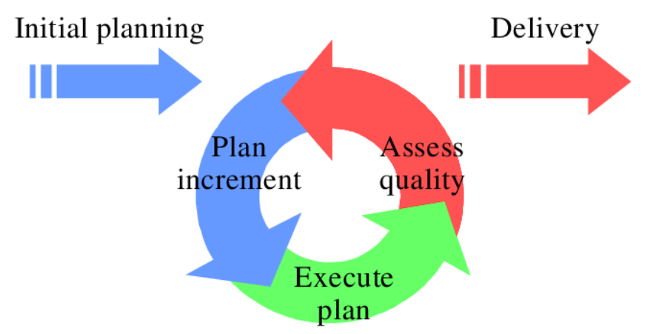
Figure (1.6.1): Incremental and iterative development model
Figure (1.6.1) illustrates the steps of the incremental iterative development methodology adopted in this project, where the work was divided into several successive iterations, with each iteration beginning by adding new functionalities or improving previous functionalities, leading to the construction of a complete and ready-to-use system.
Explanation of the chart elements:
• Iterations (Iteration 1, Iteration 2, Iteration 3): These represent sequential stages in the system development process, where each iteration adds new functionalities such as user management, patient management, appointment management, and medical records.
• Horizontal arrows: These indicate the gradual transition between iterations, reflecting the continuous development process of the system.
• Feedback: This represents the review and evaluation processes conducted after each iteration, aimed at improving performance and correcting errors before moving to the next stage.
• Final Product: This represents the integrated system achieved after completing all iterations, which becomes ready for use within the medical center.
This methodology helps ensure development flexibility, improve system quality, and better meet user requirements, while reducing the risks associated with developing complex software systems.

1.7 Summary
This chapter provides a brief description of the medical center management system, where the project objectives and its importance in improving the efficiency of daily operations and facilitating the management of patients, appointments, and medical records have been identified. It also clarifies the project boundaries and scope, along with the challenges and problems that were identified and formed the main motivation for developing and proposing this system.
The chapter also discusses the adopted development methodology, which is the Iterative & Incremental Development methodology. This approach aims to ensure efficient and effective project implementation, with the possibility of continuous evaluation and improvement throughout each development stage. It contributes to ensuring system quality, reducing errors, and achieving the desired objectives in a gradual and organized manner.
Through this chapter, the reader becomes familiar with the project idea, the problems it addresses, its objectives, and the importance of its implementation in medical center environments, which lays the foundation for understanding the remaining system details and functionalities in the following chapters.

Chapter Two
Research and Study Topic Reference

2.1 Introduction
This chapter addresses the clarification of the main fundamental concepts related to the medical center management system, with a focus on how to automate and organize daily administrative and medical processes in a more efficient and professional manner. The chapter aims to introduce the reader to the terminology and technologies used in healthcare management systems, as well as to explain the components of the proposed system and its objectives.
It also highlights how integration between the electronic system and the operational needs of medical centers is achieved, ensuring improved quality of healthcare services, facilitating the management of patients and appointments, and reducing administrative and medical errors resulting from reliance on traditional methods.

2.2 Basic Concepts
Patient Management
This is the process of registering and organizing patient data within the system, including personal information, medical history, previous visits, and health conditions. This concept aims to facilitate access to patient data and improve the accuracy of medical documentation.
Medical Appointment Management
This involves scheduling and organizing examination and consultation appointments, while defining doctors’ working hours and avoiding scheduling conflicts. The system also supports sending automatic notifications to remind patients and doctors of scheduled appointments.
Medical Staff Management
This concept includes organizing the data of doctors and medical staff, defining their specialties, working hours, and system permissions. This helps improve coordination between medical and administrative staff.
Medical Records Management
The system provides the ability to store and archive medical records electronically, enabling easy, secure, and organized access to patient information. This concept supports the protection of medical data and ensures quick access when needed.
Medical and Administrative Reports
The system enables the generation of periodic reports related to the number of patients, appointments, medical performance, and payments. This helps the medical center’s management monitor operations and make decisions based on accurate data.

.

2.3 Reference study

Practo Platform
It is a global electronic platform aimed at facilitating the management of clinics and medical centers. It provides services for online appointment booking, patient data management, and doctor schedule organization. The platform helps patients easily access medical services, while also supporting doctors in efficiently managing their clinics.
Clinic Management System
This is an electronic system designed specifically for managing medical clinics. It enables patient registration, appointment management, medical record storage, and invoice generation. The system features a user-friendly interface, which helps improve workflow and reduce reliance on paper records.
Zocdoc Platform
This platform provides online medical appointment booking services, allowing patients to search for doctors based on specialty and location and book appointments easily. It also helps doctors organize their schedules and improve the efficiency of communication with patients.

2.3.1 Comparison between the previous platforms and the current platform
The previous systems are similar in providing appointment and patient management services, but the system proposed in this project is distinguished by offering an integrated platform that combines medical and administrative management in a single system. The current system also focuses on simplifying the internal operations of the medical center, enhancing the security of medical data, and customizing permissions according to user roles, making it more suitable for the needs of local medical centers compared to general platforms.

Feature | Angel Infotech CMS | Heltog CMS | Ray by Practo | Our system
Add new patient | ✅ | ✅ | ✅ | ✅
Edit patient information | ✅ | ❌ | ❌ | ✅
Search patient | ❌ | ✅ | ❌ | ✅
Book appointment | ✅ | ✅ | ✅ | ✅
Edit appointment | ✅ | ✅ | ❌ | ✅
Cancel appointment | ✅ | ❌ | ✅ | ✅
View doctor’s daily schedule | ✅ | ❌ | ✅ | ✅
Manage doctor availability | ❌ | ✅ | ✅ | ✅
Add medical notes for patient | ❌ | ✅ | ❌ | ✅
View monthly reports | ✅ | ❌ | ✅ | ✅

2.4 Components of the proposed system
1. Periodic Evaluation
The system provides a mechanism for periodic evaluation of the medical center’s performance by monitoring daily workflow, appointment management efficiency, and the quality level of healthcare services provided. It also enables the preparation of regular evaluation reports that help management identify strengths and weaknesses and continuously improve medical and administrative processes.
2. Analytical Reports
The system supports the generation of monthly or quarterly analytical reports that illustrate the performance of the medical center in terms of the number of patients and completed appointments. These reports provide accurate statistics that help doctors and management make decisions based on reliable data.
3. Management Reports
The system provides comprehensive administrative reports related to productivity, human and medical resource management, and overall performance monitoring of the medical center. These reports also include indicators that help management assess the level of work, provide recommendations for improving performance, and ensure continuous development.

Chapter Three
Analytical Study of the Proposed System

3.1 Introduction
In this chapter, a comprehensive analytical study of the medical center management system will be presented, where the technical and financial feasibility of the project is evaluated from several perspectives. This study includes an analysis of the available technical resources and an assessment of the possibility of implementing the proposed system within the medical center environment, taking into consideration the nature of medical and administrative work.
It will also evaluate the level of acceptance of the system by medical staff, administrative staff, and patients, as well as its impact on improving the efficiency of daily operations and the quality of healthcare services provided. In addition, a Gantt Chart will be presented to illustrate the project timeline and the distribution of key tasks over specific time periods.
A Requirements Document will also be provided, defining the functional and non-functional requirements of the system, such as patient management, appointment management, medical records, and user management. Furthermore, a set of detailed diagrams will be presented to illustrate the system structure, such as the Use Case Diagram, which shows user interaction with the system, and Sequence Diagrams, which illustrate the flow of operations between system components.
Finally, a list of tests for each use case will be presented, with the results summarized in a Requirement Traceability Matrix to ensure that the system meets all specified requirements efficiently and accurately.

3.2 Feasibility study
In this phase, the project feasibility is analyzed by evaluating a set of key factors to determine the possibility of successfully implementing the proposed system within medical centers. These factors include:
1. Economic Feasibility
The total cost of the project is evaluated, including development, maintenance, and training costs, compared to the expected returns from improving work efficiency and reducing operational costs. The economic benefits are also analyzed, such as saving time and effort in managing patients and appointments, and reducing administrative errors that may lead to financial losses.
2. Technical Feasibility
This involves evaluating the available technical capabilities, such as technological infrastructure, databases, and software systems used. It also includes analyzing the development team’s ability to implement the system and its compatibility with existing technologies and systems used within medical centers.
3. Social Feasibility
This evaluates the level of acceptance of the new system by medical staff, administrative staff, and patients, as well as its impact on improving the patient experience and increasing satisfaction. It also examines the role of the system in facilitating communication between patients, reception staff, and doctors.
4. Operational Feasibility
This assesses the system’s ability to improve daily operations within the medical center, such as appointment scheduling, medical record management, and coordination between medical and administrative staff. It also analyzes the system’s impact on increasing employee productivity and reducing human errors.
5. Expected Outputs
After completing the feasibility study, a detailed report will be prepared outlining the findings and recommendations. A work plan will also be presented, including the project timeline, required tasks, and proposed budget. The ultimate goal is to ensure that the proposed system is feasible and capable of achieving the desired objectives in terms of improving work efficiency, healthcare service quality, and patient satisfaction.

3.3 Project plan:

3.3.1 GANTT CHART
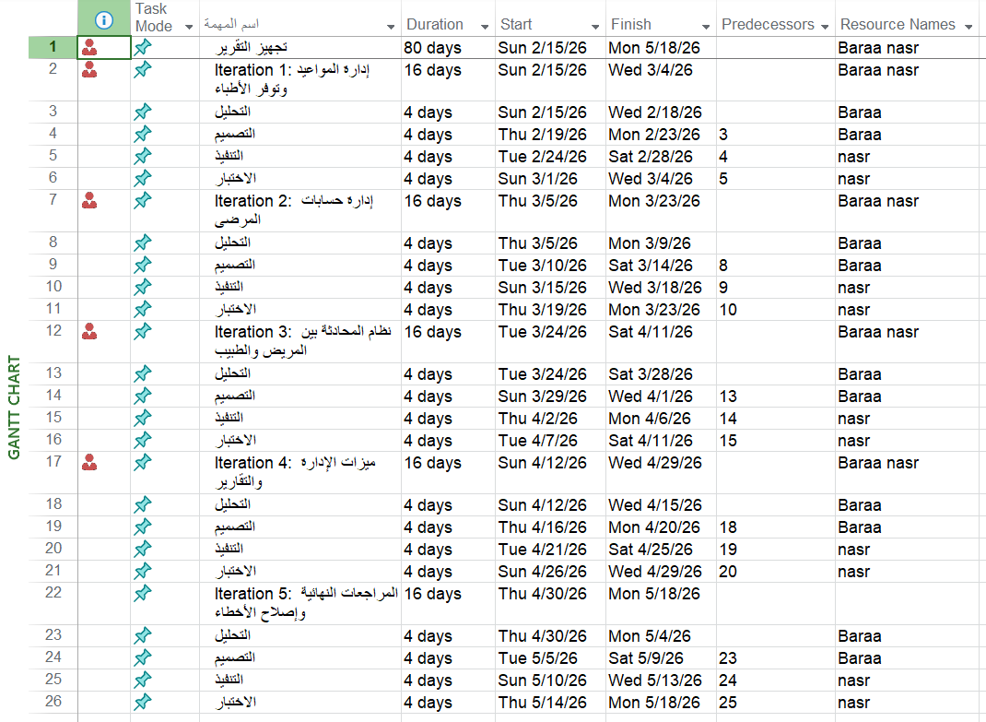
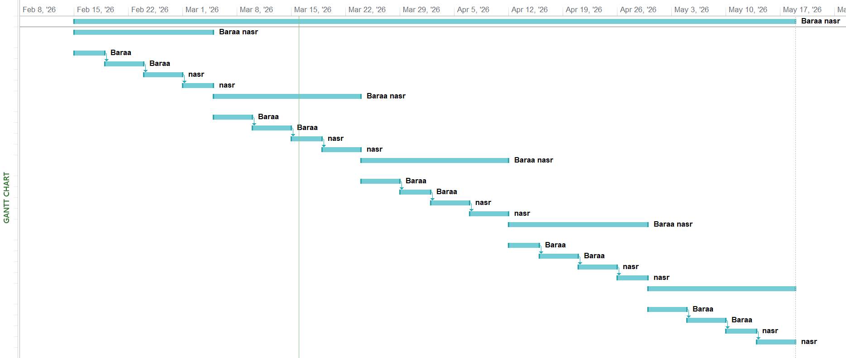

3.4.1 Problem Definition
Medical centers face many challenges in managing daily operations, which directly affects work efficiency and the quality of healthcare services provided to patients. These challenges include:
1. Data and Medical Records Management
Many medical centers rely on manual methods or non-integrated systems to manage patient records, which leads to time loss, difficulty in accessing information, and an increased likelihood of losing or duplicating important medical data.
2. Medical Appointment Scheduling
Reception staff and doctors face difficulties in effectively organizing medical examination and consultation appointments, which leads to scheduling conflicts, long waiting times, and failure to adhere to planned schedules.
3. Communication with Patients
The medical center suffers from weak effective communication with patients, whether regarding appointment confirmation, sending reminders, or informing patients about updates related to their health condition, which negatively affects patient experience and satisfaction.
4. Follow-up of Medical Cases
The lack of a centralized system for tracking medical cases and continuously updating records makes it difficult for doctors to accurately follow a patient’s medical history, which may lead to delays in providing healthcare or making inaccurate medical decisions.
5. Reports and Analytics
Traditional systems do not provide accurate analytical reports that help medical center management monitor performance, analyze the number of patients, appointments, and revenues, and make data-driven administrative decisions based on reliable information.

3.4.2 The purpose of the system
The purpose of this document is to provide a detailed requirements specification for the medical center management system. The system aims to improve the efficiency of administrative and medical operations by providing integrated tools for managing patients, appointments, medical records, and medical staff. This document also defines the core functionalities of the system, the constraints that must be considered, and the way users interact with the system.

3.4.3 The main functions of the system
1. Patient Management
- Recording patient data and storing it in a centralized and secure manner.
- Monitoring medical history and patient conditions in an organized way.
2. Appointment Management
- Organizing medical examination and consultation appointments.
- Sending automatic reminders and notifications to patients and doctors.
3. Medical Staff Management
- Recording doctors’ data and defining their specialties and working hours.
- Allowing doctors to view their daily schedules and add medical notes.
4. Medical Records Management
- Storing and archiving medical records electronically in a secure manner.
- Enabling quick search of medical records and linking them to patients.
5. Reports and Analytics
- Generating detailed reports on the number of patients, appointments, and overall performance of the medical center.

3.4.4 Target users
1. Doctors
- Using the system to follow up on patients and appointments.
- Accessing medical records and adding medical notes and reports.
2. Patients
- Viewing their medical appointments and receiving notifications and reminders.
- Accessing certain authorized health information through the system.
3. Reception and Administrative Staff
- Managing patient data and daily appointments.
- Managing users and permissions and generating administrative reports.

3.4.5 Functional Requirements

ID | Requirements | Actor
FR-1 | Login | Admin, Receptionist, Doctor
FR-2 | Logout | Admin, Receptionist, Doctor
FR-3 | Add doctor | Admin
FR-4 | Delete doctor | Admin
FR-5 | Add receptionist | Admin
FR-6 | Delete receptionist | Admin
FR-7 | View complaints | Admin
FR-8 | Add specialization to doctor | Admin
FR-9 | Add patient | Receptionist
FR-10 | Search for patient | Receptionist
FR-11 | Book appointment | Receptionist
FR-12 | Edit appointment | Receptionist
FR-13 | Cancel appointment | Receptionist
FR-14 | Record payments | Receptionist
FR-15 | Edit patient information | Receptionist
FR-16 | Monthly reports | Receptionist
FR-17 | Send notification to doctor | Receptionist
FR-18 | View doctor's availability | Receptionist
FR-19 | Create account by patient | Patient
FR-20 | Edit patient account | Patient
FR-21 | Patient views doctors' appointments | Patient
FR-22 | Book appointment | Patient
FR-23 | Edit appointment | Patient
FR-24 | Cancel appointment | Patient
FR-25 | Patient receives appointment notifications | Patient
FR-26 | Conduct conversation with doctor | Patient
FR-27 | Send text messages | Patient
FR-28 | Send photos or files | Patient
FR-29 | Give rating or complaint | Patient
FR-30 | Receive sent messages | Doctor
FR-31 | View messages | Doctor
FR-32 | Reply to messages | Doctor
FR-33 | Set availability times | Doctor
FR-34 | View appointments | Doctor
FR-35 | View patient information | Doctor
FR-36 | Add medical notes | Doctor

3.4.6 Non-Functional Requirements
Non-functional requirements define the general qualities the system must have to ensure ease of use, data security, and reliable performance
- Usability
The system should be easy to understand and use. Pages, buttons, and messages should be clear so that staff can learn the system quickly.
- Performance
Basic actions such as logging in, searching for a patient, or opening the appointments page should respond within a few seconds under normal use.
- Reliability
The system should run in a stable way during the medical center’s working hours.
- Security
  - Only logged-in users can access the system.
  - Each role can only see and do what is allowed for that role.
  - Passwords are stored securely in the database.
- Data Integrity
All patient, appointment, and payment data should be stored in a single database.

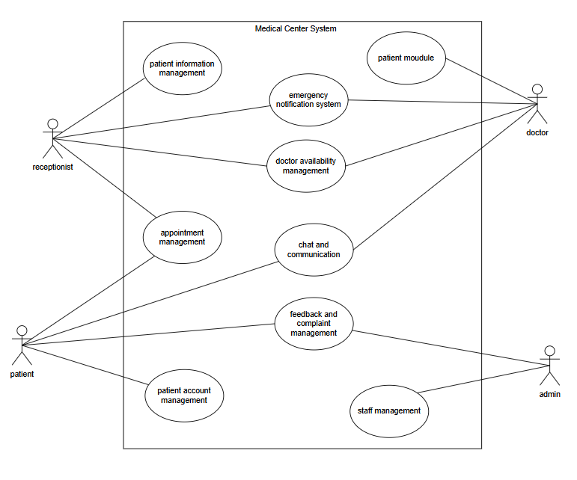
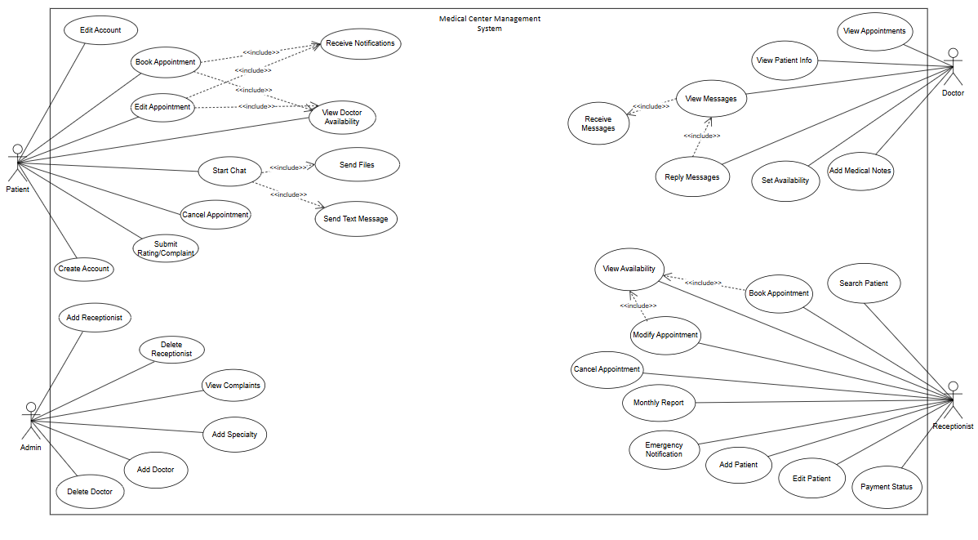
Use case diagram (high level):
Use case diagram (low level ):

3.4.7 Use case specification:

Field | Details
Use Case | Login
Use Case ID | UC-01
Actor | Admin, Receptionist, Doctor
Goal | Log into the system using email and password.
Preconditions | User account exists.
Main Flow | 1) Open login page  2) Enter email and password  3) System validates  4) System redirects to dashboard based on role
Alternative Flow | If credentials are wrong show error
Postconditions | User is logged in.

Field | Details
Use Case | Logout
Use Case ID | UC-02
Actor | Admin, Receptionist, Doctor
Goal | Log out from the system.
Preconditions | User is logged in.
Main Flow | 1) Click Logout  2) System ends session  3) Return to login page
Alternative Flow | None
Postconditions | User is logged out.

Field | Details
Use Case | Add Doctor
Use Case ID | UC-03
Actor | Admin
Goal | Add a new doctor account.
Preconditions | Admin is logged in.
Main Flow | 1) Open staff management  2) Click Add Doctor  3)Enter details  4) Save  5) System creates doctor user
Alternative Flow | Missing or duplicate email shows validation error.
Postconditions | Doctor account is created.

Field | Details
Use Case | Delete Doctor
Use Case ID | UC-04
Actor | Admin
Goal | Remove a doctor account.
Preconditions | Admin is logged in and doctor exists.
Main Flow | 1) Open doctors list  2) Select doctor  3) Click Delete  4) Confirm  5) System deletes doctor
Alternative Flow | Doctor has appointments system warns.
Postconditions | Doctor removed

Field | Details
Use Case | Add Receptionist
Use Case ID | UC-05
Actor | Admin
Goal | Add a new receptionist account.
Preconditions | Admin is logged in.
Main Flow | 1) Open staff management  2) Click Add Receptionist  3) Enter details  4) Save  5) System creates receptionist user
Alternative Flow | None
Postconditions | Receptionist account created.
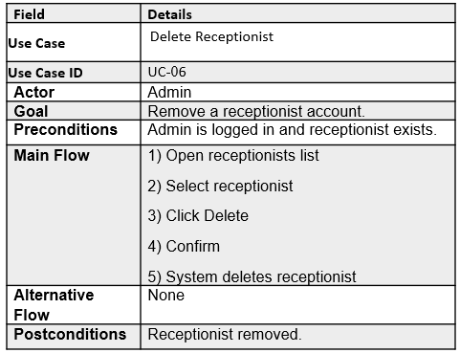

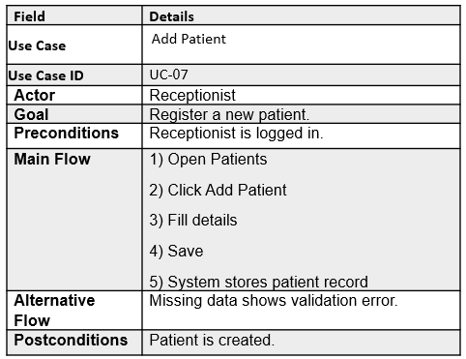

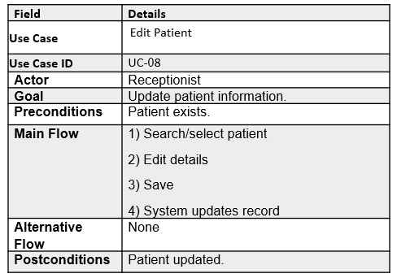
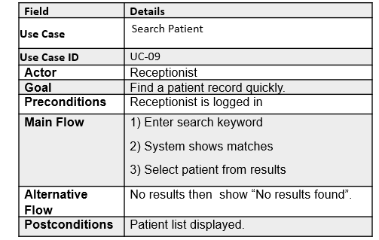

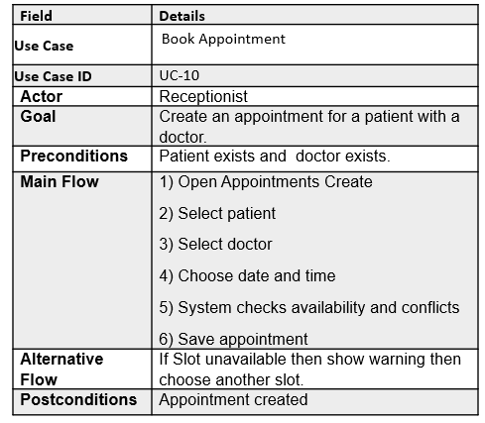
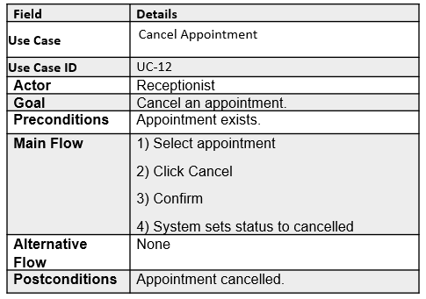
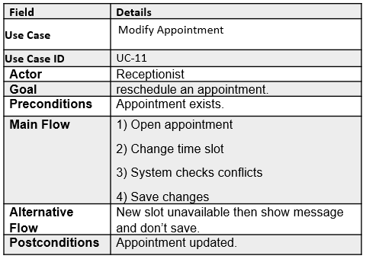
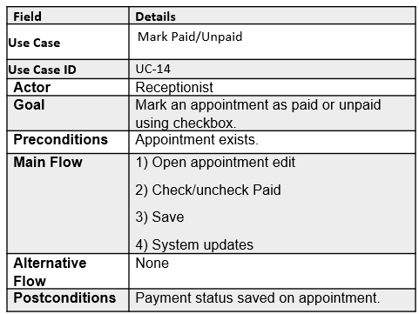
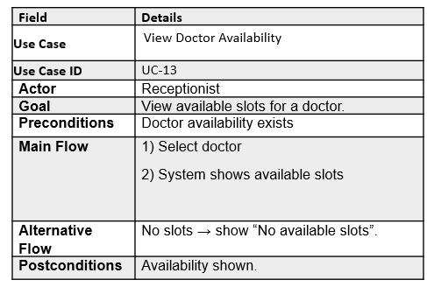
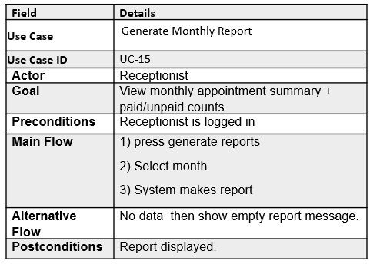

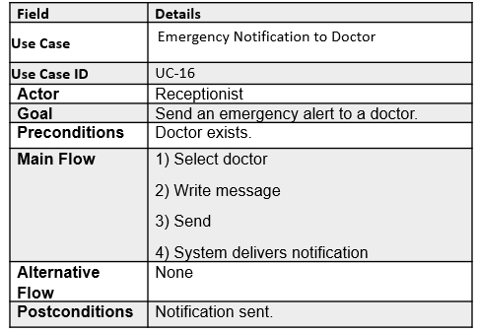
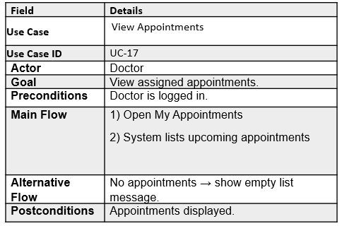

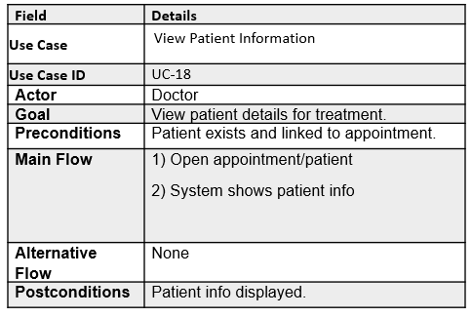

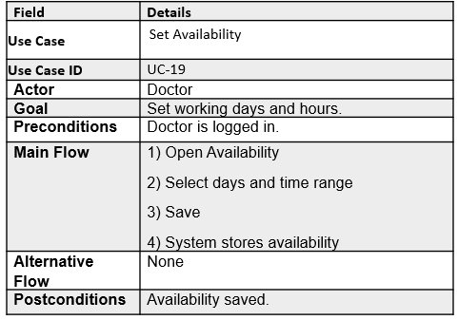
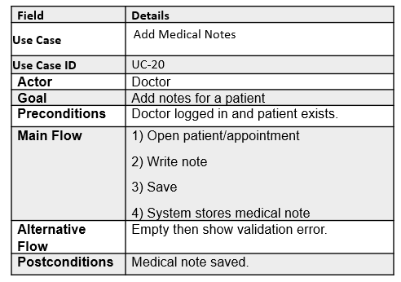

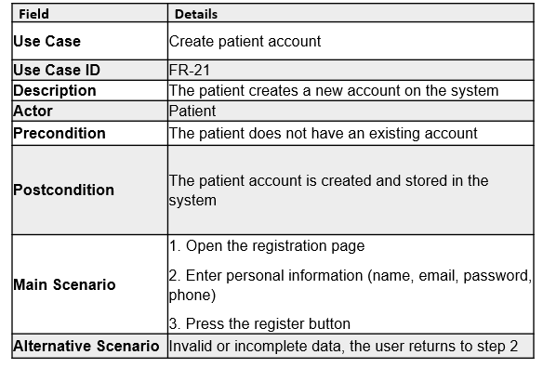

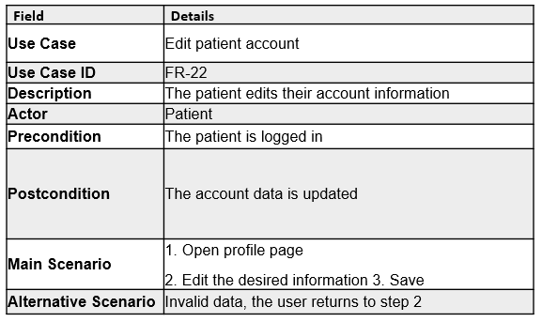

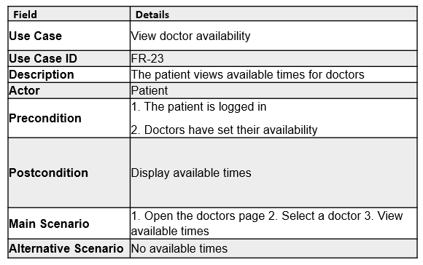

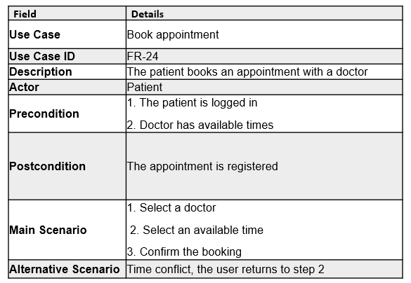

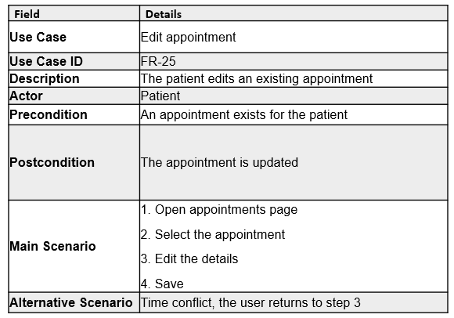
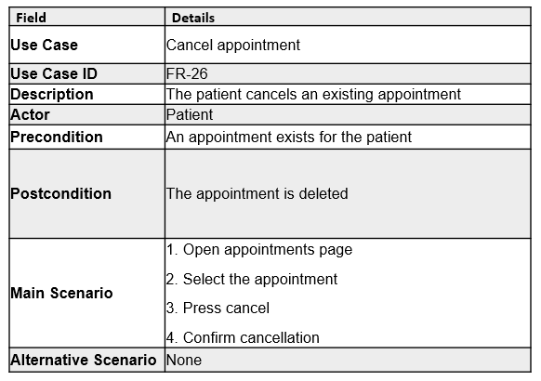
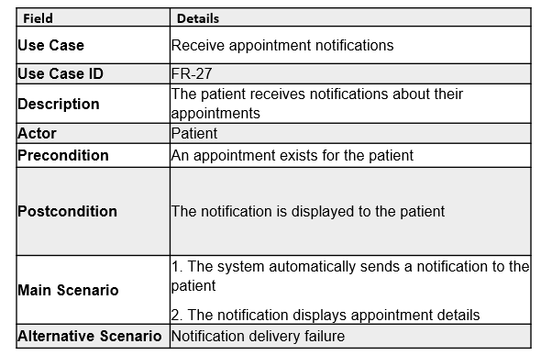

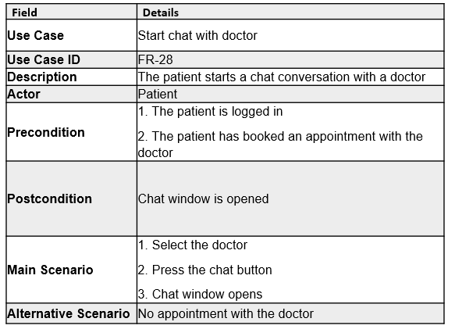
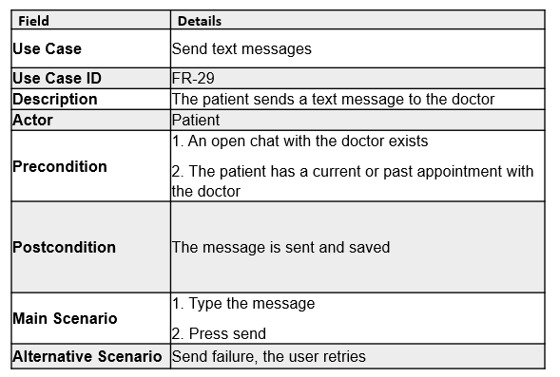
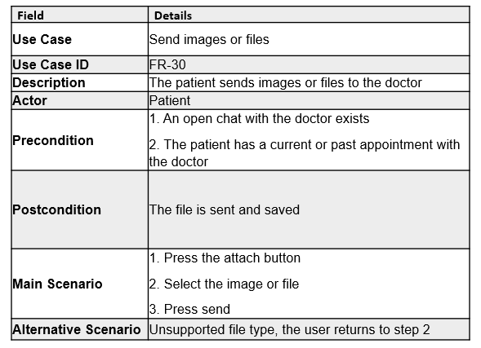
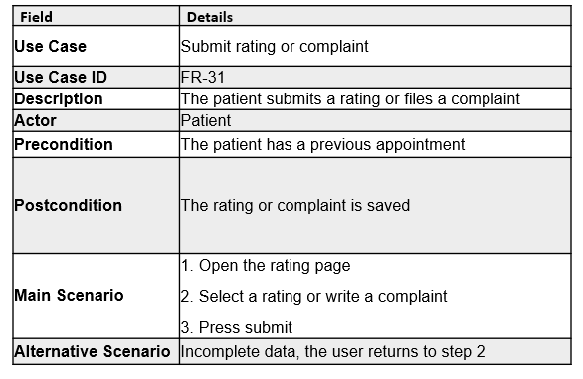

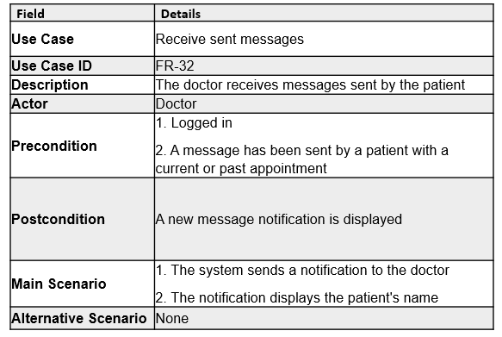
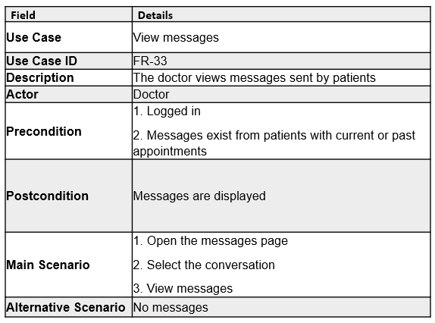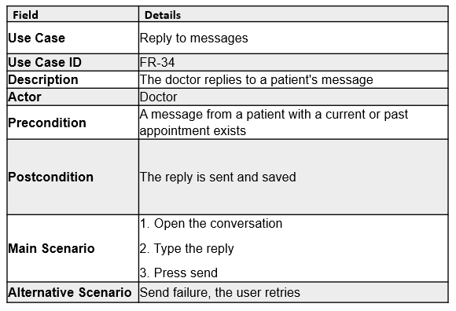

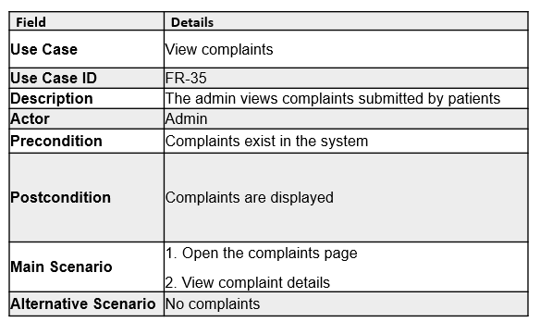
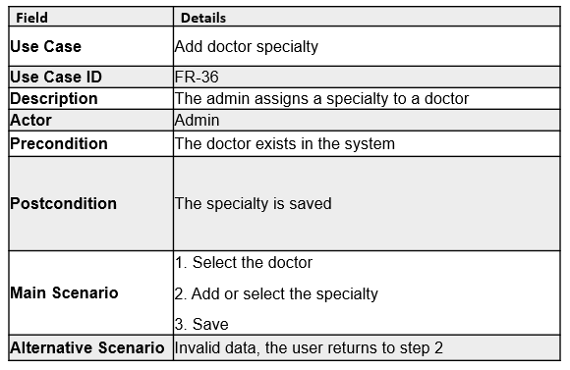

3.4.8 Activity Diagram :

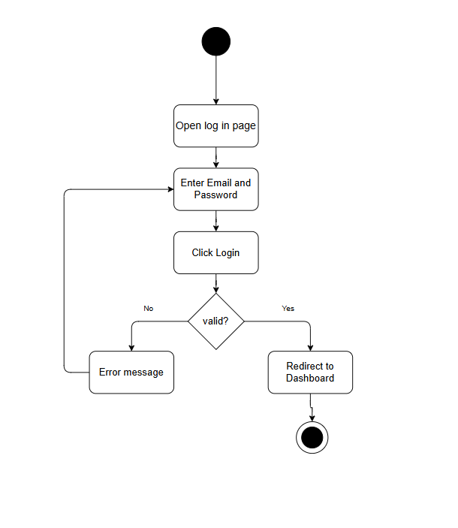
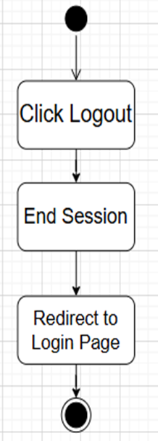

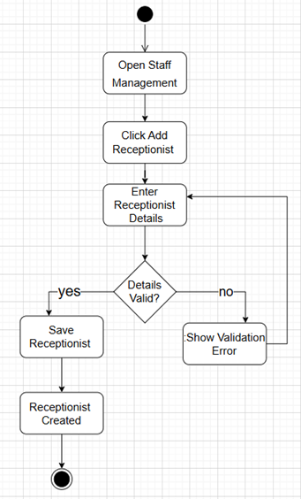
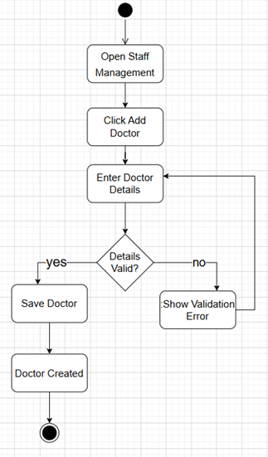

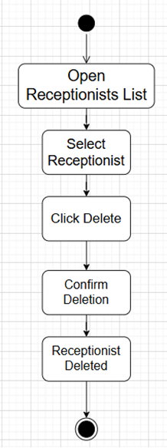
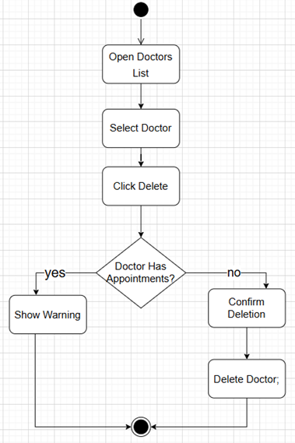

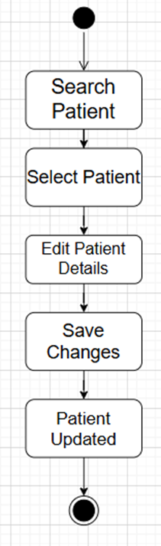
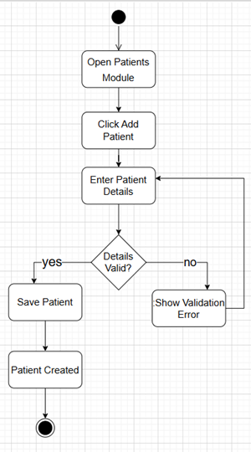

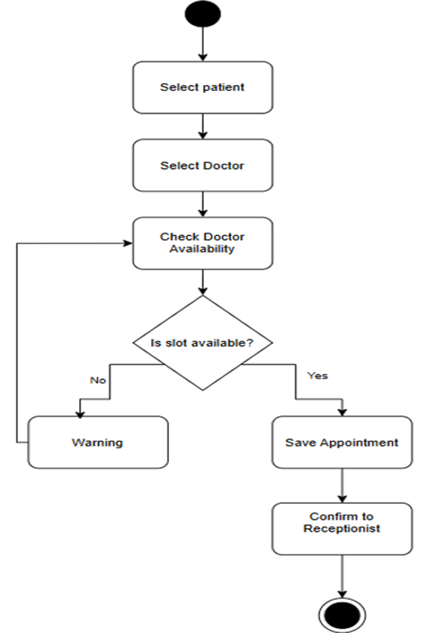
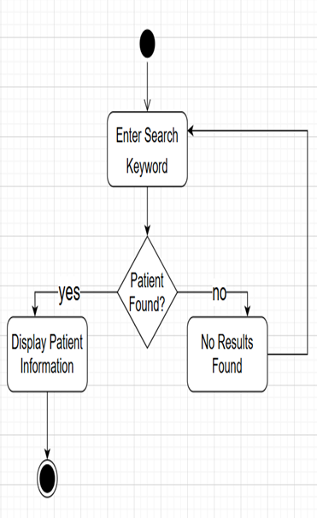

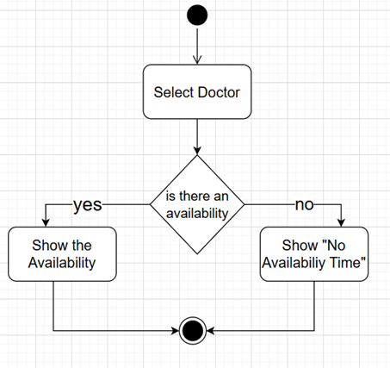
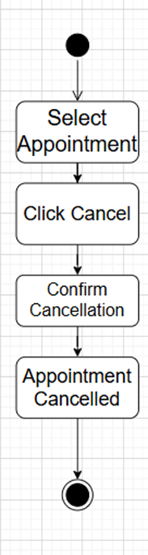
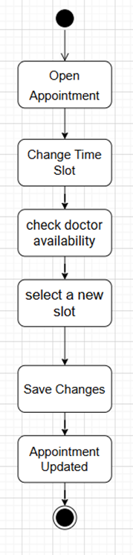

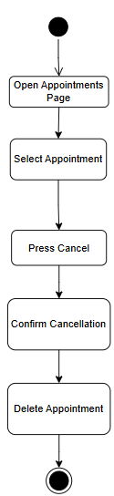
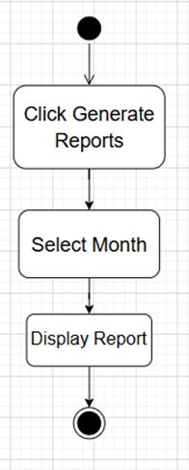
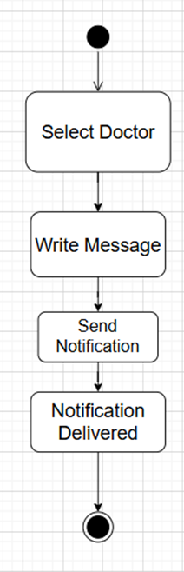
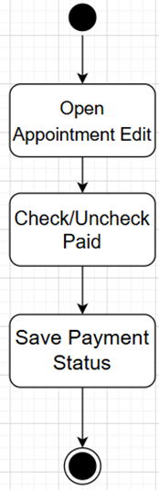

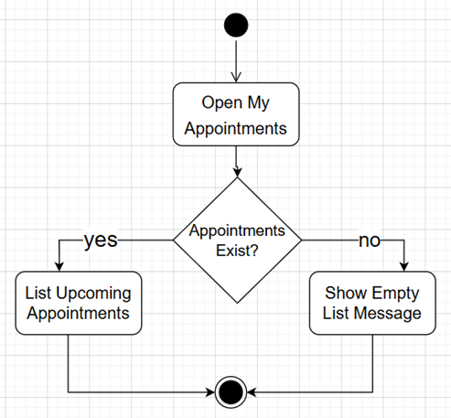
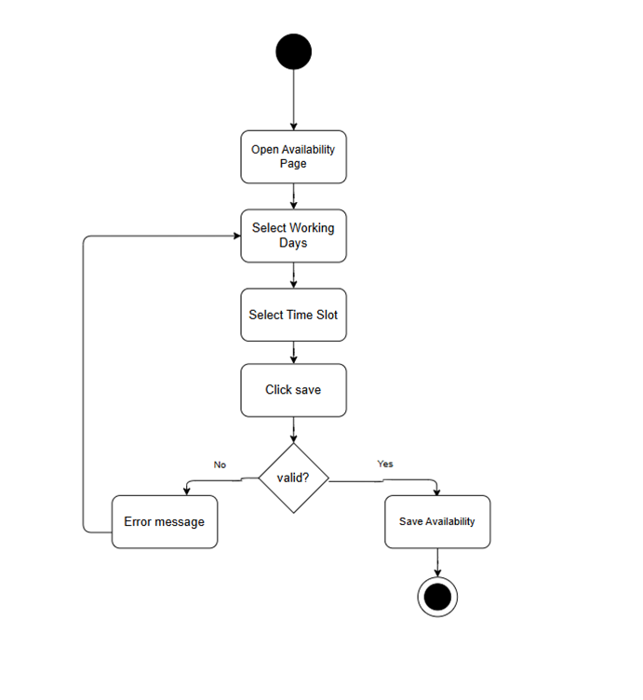
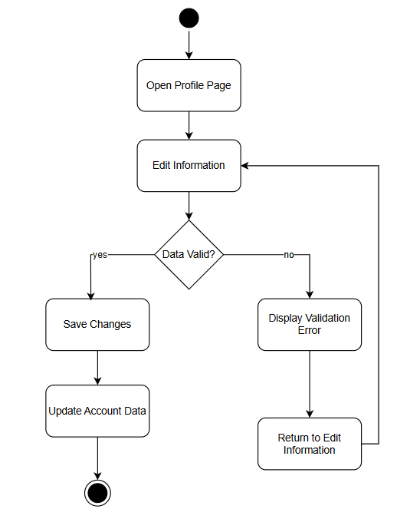
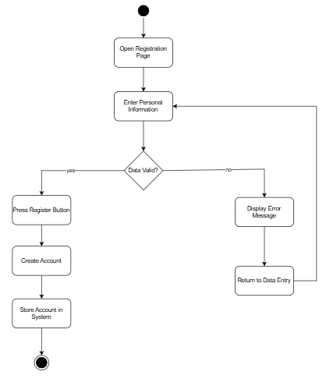

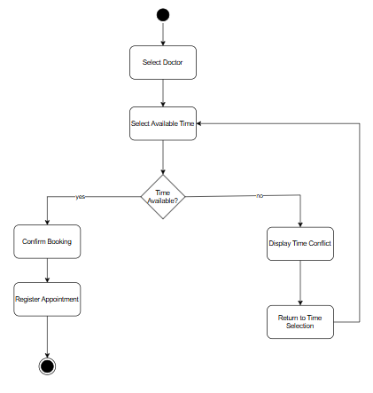
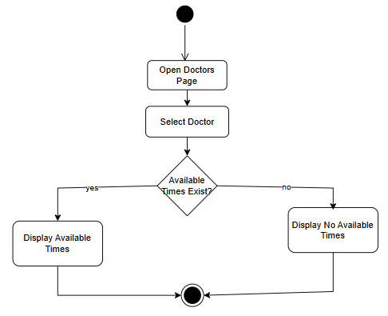
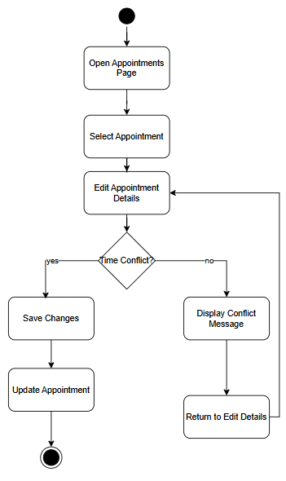
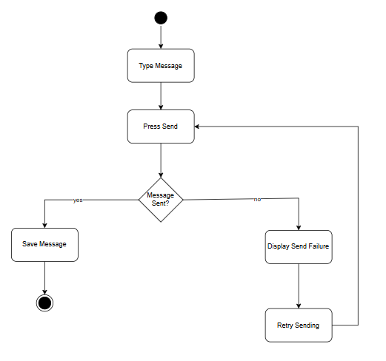
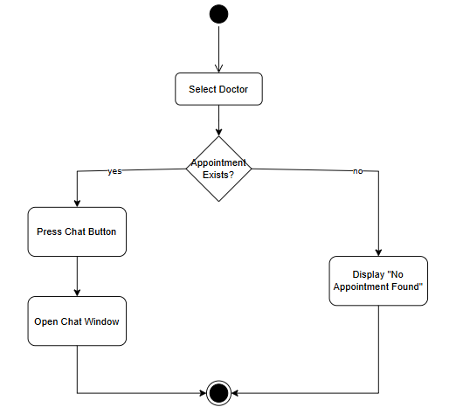
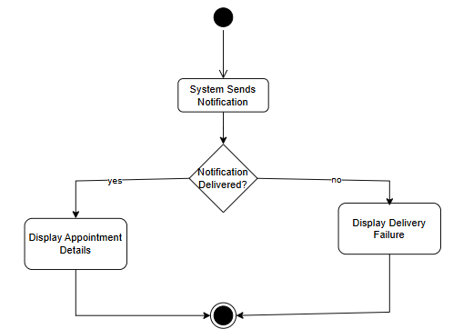
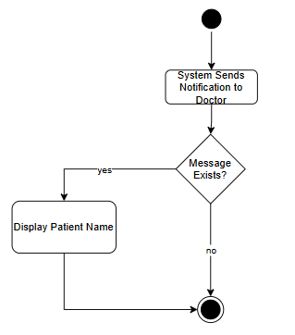
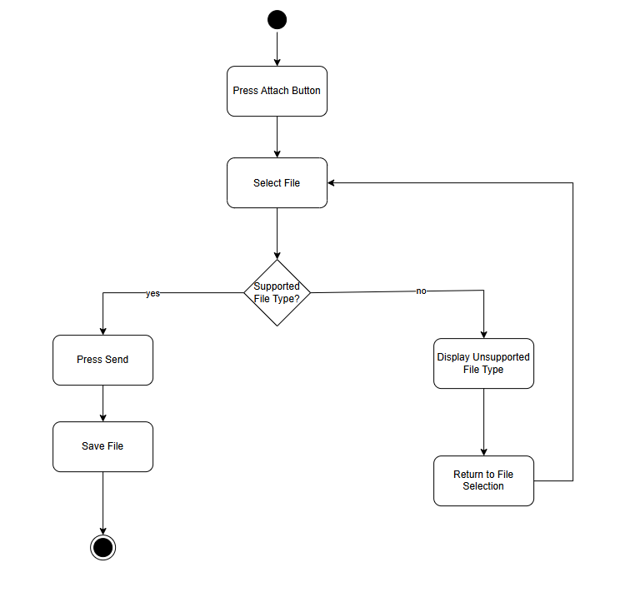
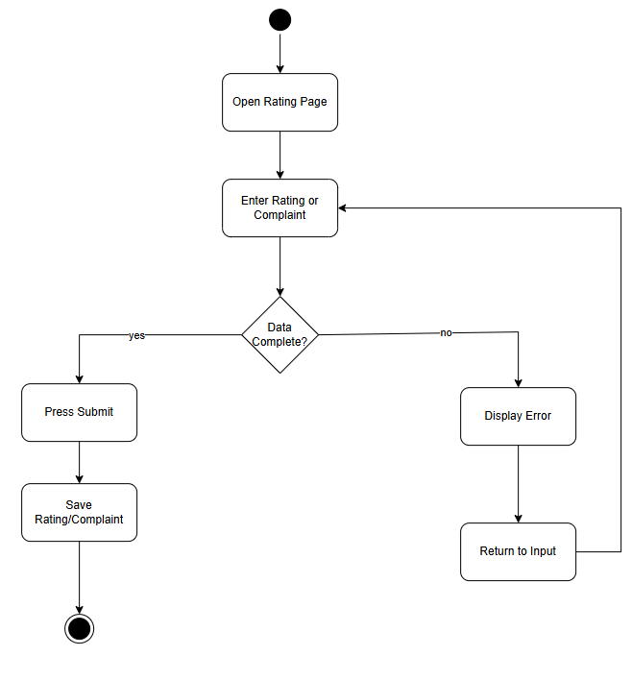
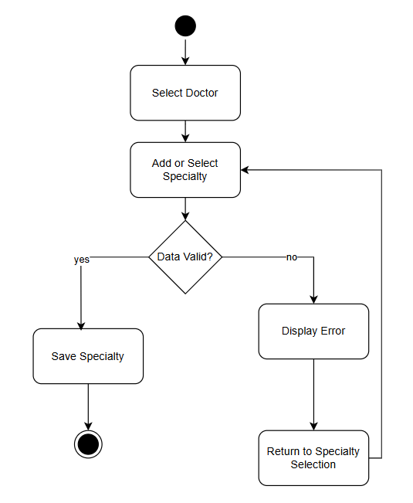
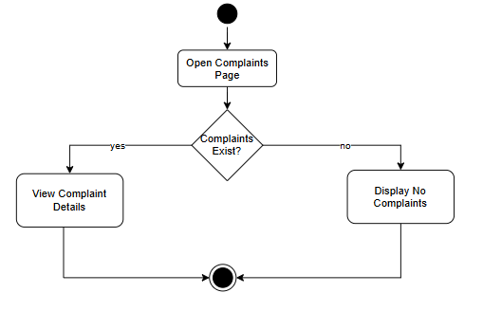
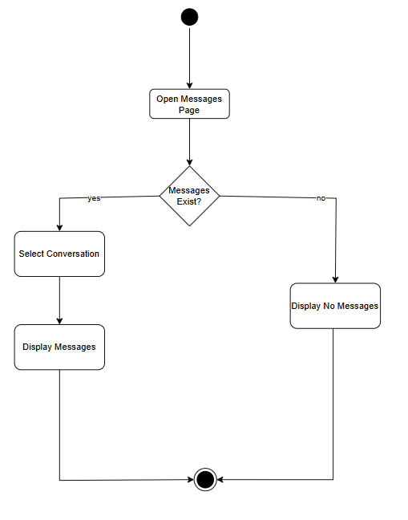
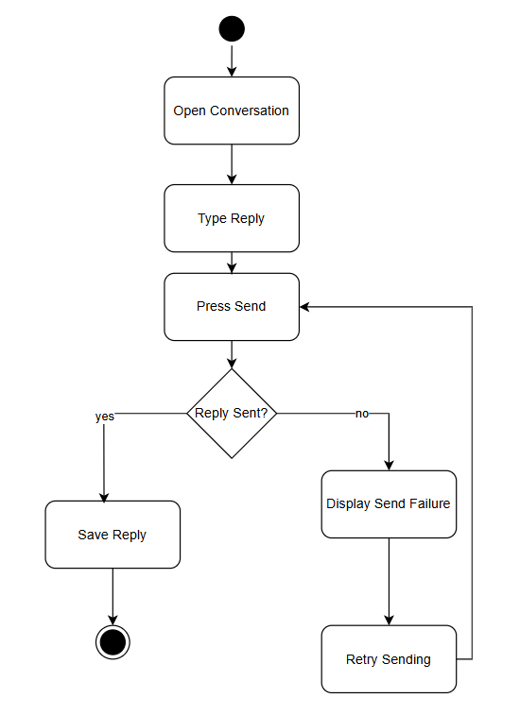

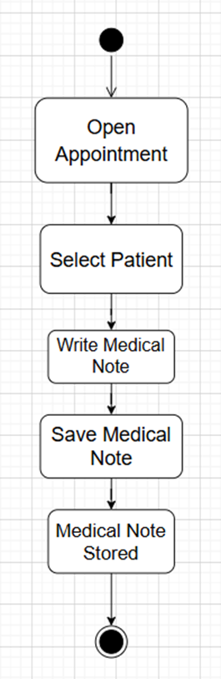
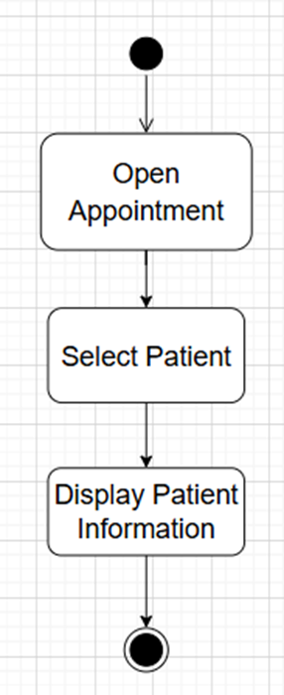
3.4.9 Sequence Diagram:

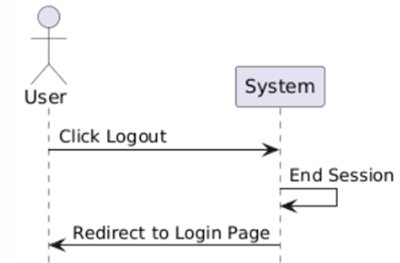
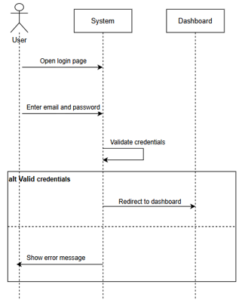

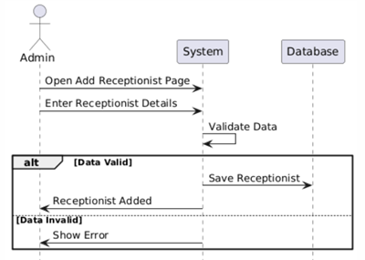
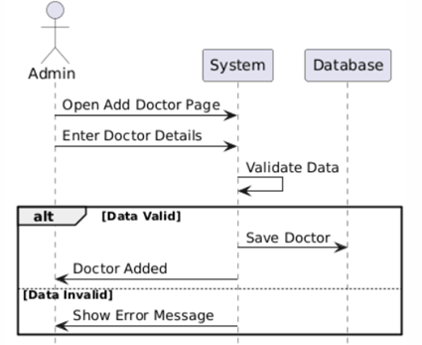
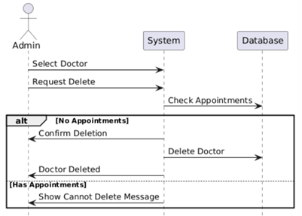
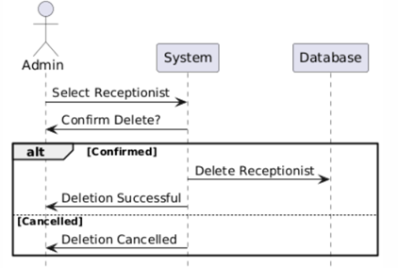
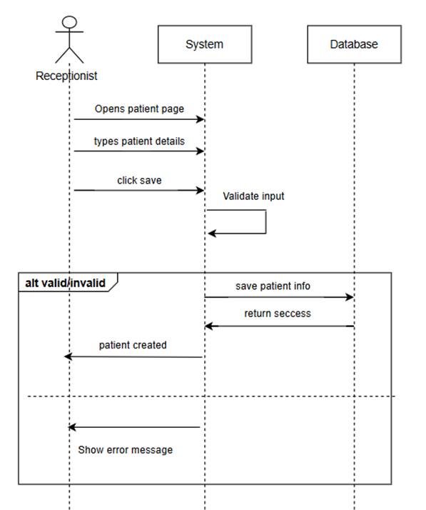
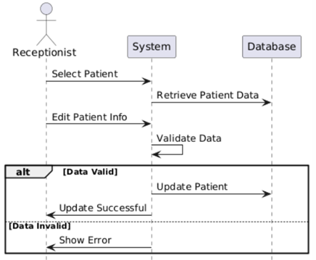
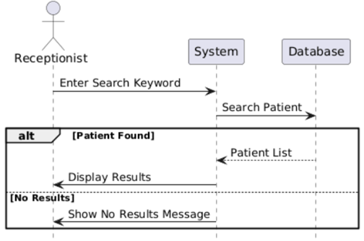
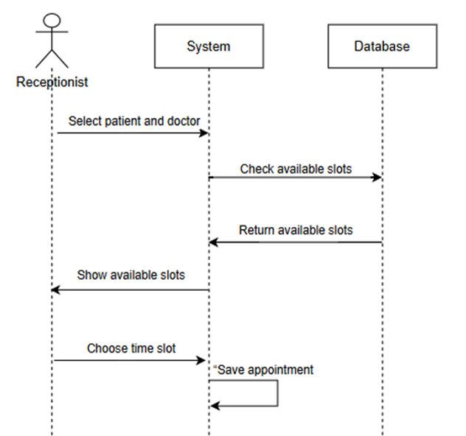
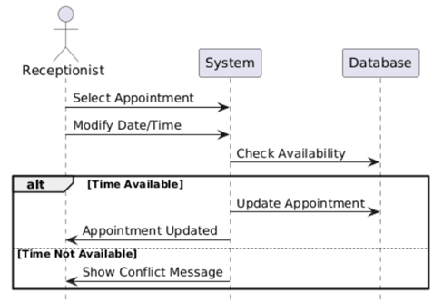
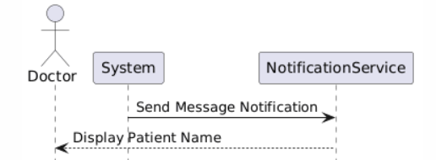
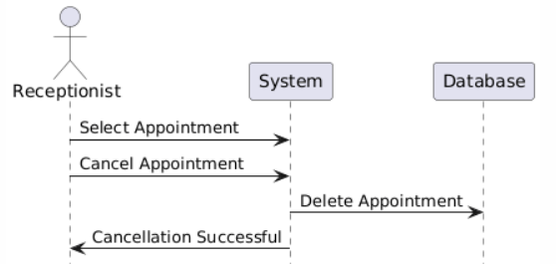
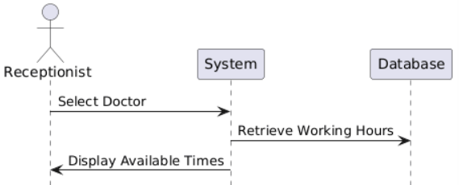
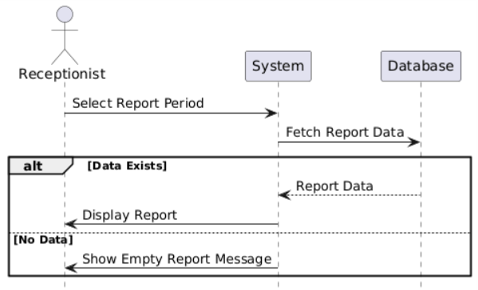
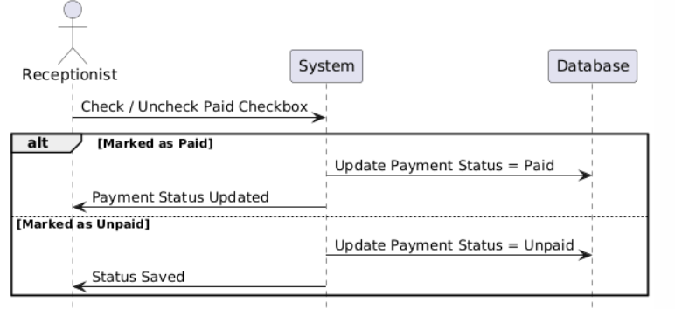
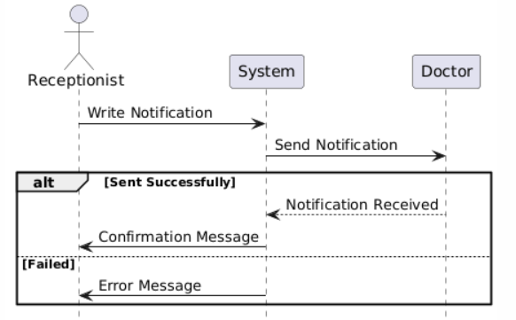
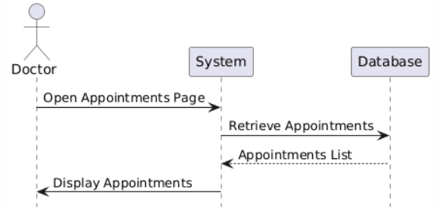
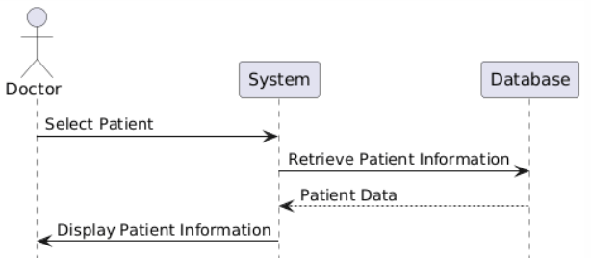
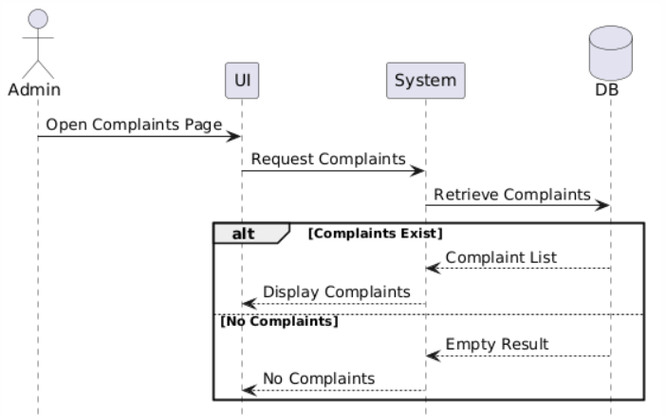
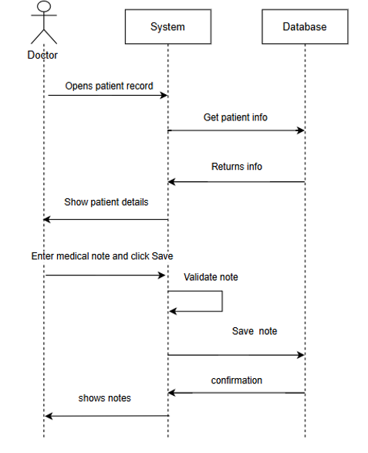
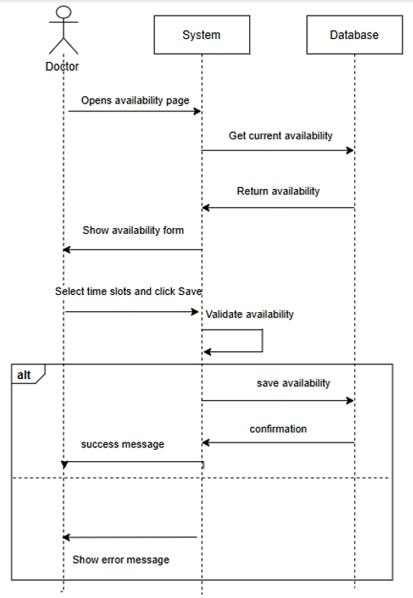
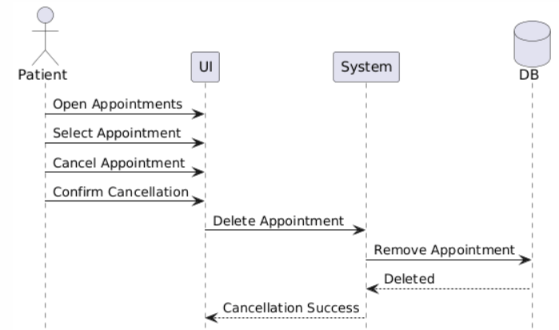
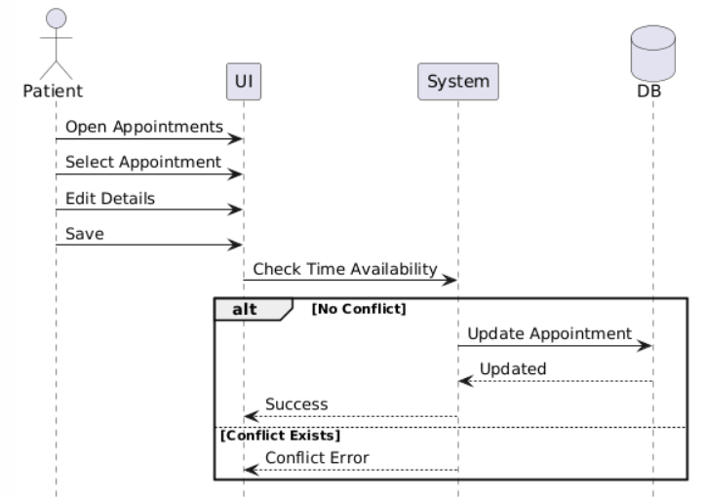
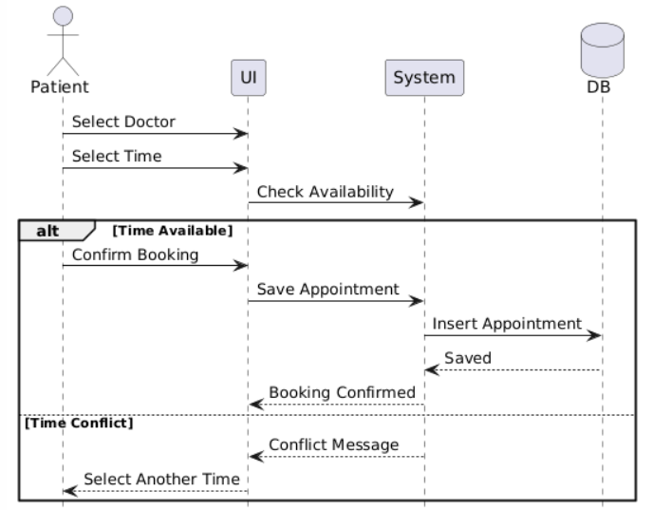
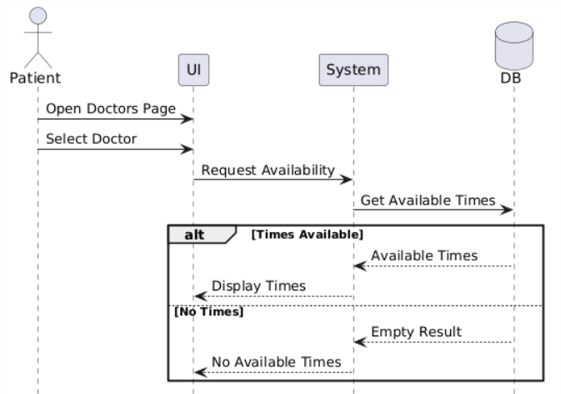
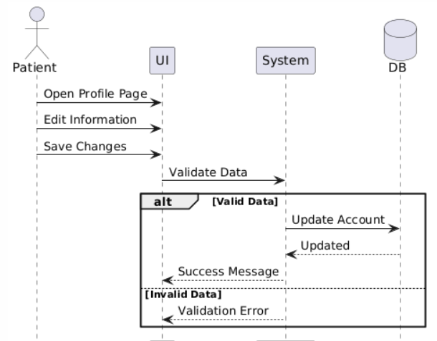
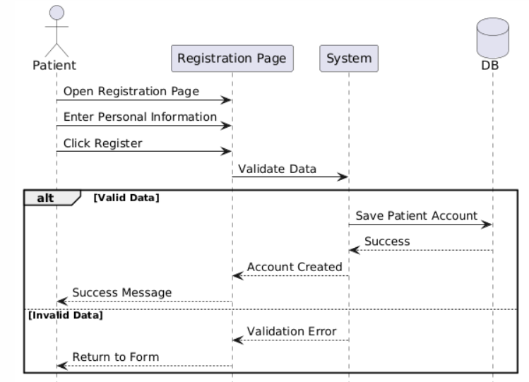
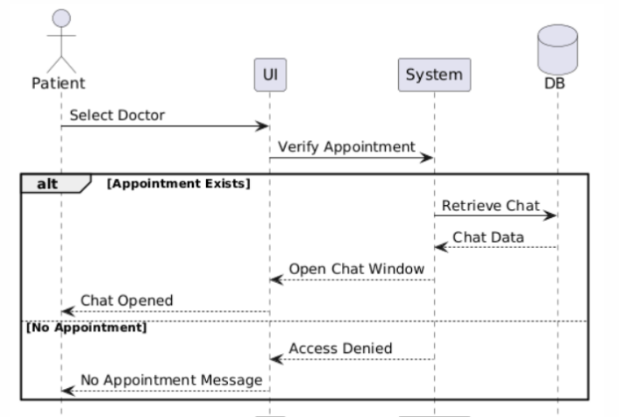
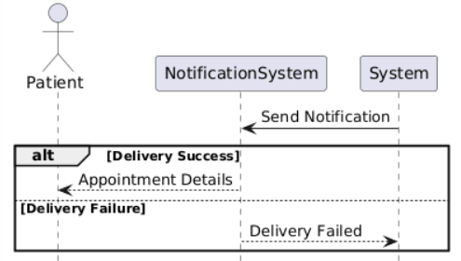
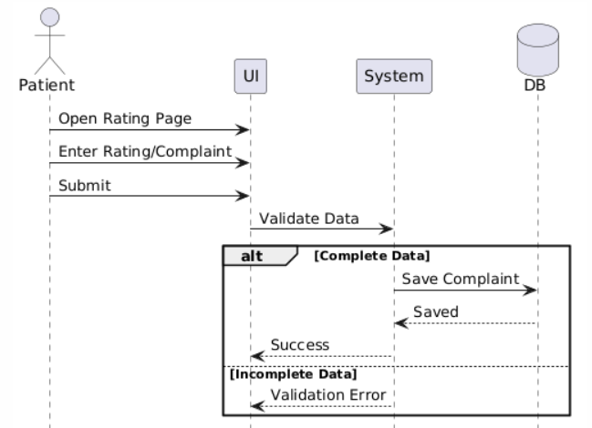
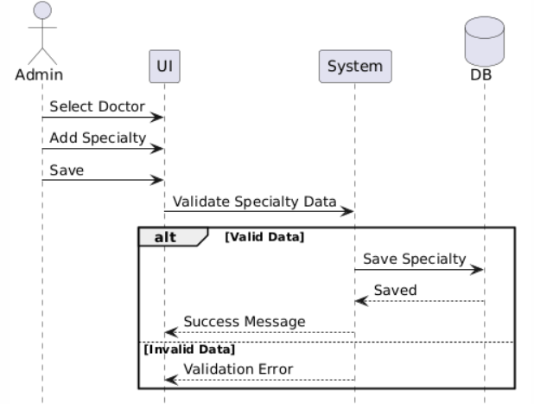
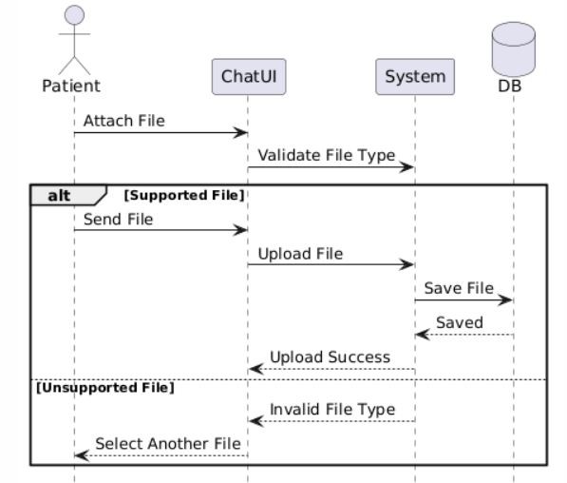
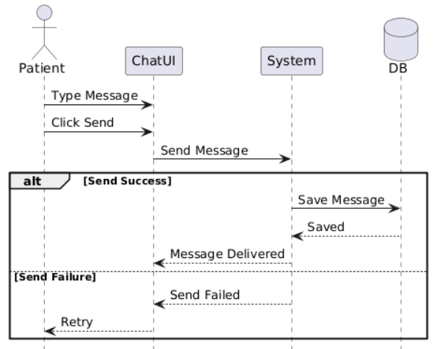
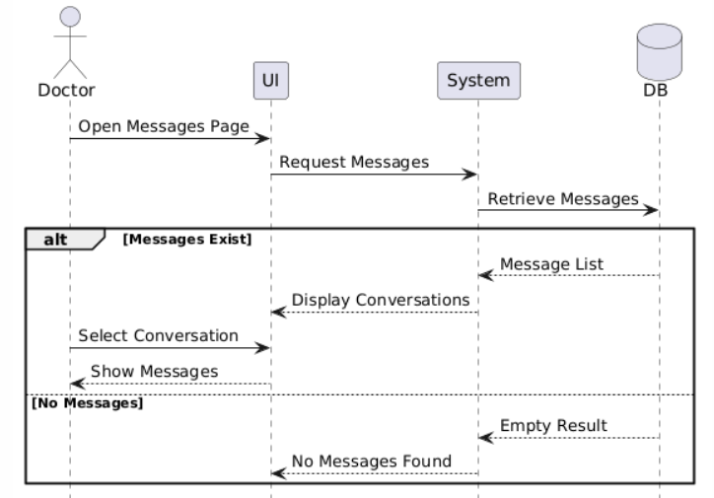
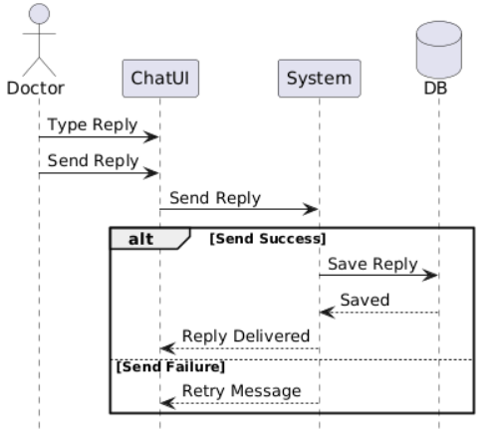

3.4.10 Unit Testing Schedule:
Test ID | Feature / FR | Preconditions | Test Steps | Expected Result | Actual Result
TC-01 | Login (FR-1) | User exists | 1) Open login  2) Enter valid email and password  3) Click Login | Redirect to correct dashboard based on role | As expected redirected to correct dashboard
TC-02 | Login invalid (FR-1) | None | 1) Open login  2) Enter wrong password  3) Click Login | Error message shown, user stays on login | As expected (error shown, stayed on login)
TC-03 | Logout (FR-2) | Logged in | 1) Click Logout | Session ends, redirected to login | As expected (logged out and returned to login)
TC-04 | Add Doctor (FR-3) | Admin logged in | 1) Staff page  2) Add Doctor  3) Fill fields  4) Save | Doctor user created with role doctor | As expected (doctor created and listed)
TC-05 | Add Doctor duplicate email (FR-3) | Admin logged in | 1) Add Doctor  2) Use existing email  3) Save | Validation error, no user created | As expected (validation error shown, no new user)
TC-06 | Delete Doctor no appointments (FR-4) | Admin logged in, doctor exists | 1) Select doctor  2) Delete  3) Confirm | Doctor removed | As expected (doctor removed successfully)
TC-07 | Delete Doctor with appointments (FR-4) | Admin logged in, doctor has appointments | 1) Select doctor  2) Delete | System shows message | As expected (message shown)
TC-08 | Add Receptionist (FR-5) | Admin logged in | 1) Staff page  2)Add Receptionist  3) Save | Receptionist account created | As expected (receptionist created and listed)
TC-09 | Delete Receptionist (FR-6) | Admin logged in, receptionist exists | 1) Select receptionist  2) Delete | Receptionist removed | As expected (receptionist removed successfully)
TC-10 | Add Patient (FR-7) | Receptionist logged in | 1) Patients  2) Add Patient  3) Fill required fields  4) Save | Patient record saved and appears in list | As expected (patient saved and appears in list)
TC-11 | Edit Patient (FR-8) | Receptionist logged in, patient exists | 1) Open patient  2) Edit fields  3) Save | Updated info saved | As expected (patient info updated)
TC-12 | Search Patient (FR-9) | Receptionist logged in, patient exists | 1) Search by keyword | Matching patient shown | As expected (matching patient returned)
TC-13 | Search Patient not found (FR-9) | Receptionist logged in | 1) Search random text | “No results” / empty list shown | As expected (no results shown)
TC-14 | View Doctor Availability (FR-13) | Receptionist logged in, doctor has availability | 1) Choose doctor + date 2) Load slots | Available slots displayed | As expected (available slots displayed)
TC-15 | Book Appointment success (FR-10) | Receptionist logged in and patient and doctor exist with slot free | 1) Create appointment  2) Pick doctor and date and time  3) Save | Appointment created | As expected (appointment created)
TC-16 | Book Appointment slot conflict (FR-10) | Slot already booked | 1) Try booking same doctor/date/time | System rejects with warning/error | As expected (conflict blocked with message)
TC-17 | Modify Appointment success (FR-11) | Appointment exists | 1) Edit appointment 2) Change time to free slot 3) Save | Appointment updated | As expected (appointment updated)
TC-18 | Modify Appointment to taken slot (FR-11) | Another appointment exists at target slot | 1) Edit appointment  2) Choose taken slot  3) Save | System rejects change | As expected (update blocked with message)
TC-19 | Cancel Appointment (FR-12) | Appointment exists | 1) Cancel appointment  2) Confirm | Status becomes cancelled, removed from active list (if filtered) | As expected (status changed to cancelled)
TC-20 | Mark Paid/Unpaid (FR-14) | Appointment exists | 1) Edit appointment  2)Toggle Paid checkbox  3) Save | is_paid updates correctly and shows on details/report | As expected (paid/unpaid updated correctly)
TC-21 | Monthly Report (FR-15) | Receptionist logged in, some appointments exist | 1) Press generate reports | Shows reports | As expected (report shows correct counts/list)
TC-22 | Doctor View Appointments (FR-17) | Doctor logged in | 1) Open My Appointments | Doctor sees only their appointments | As expected (doctor sees own appointments only)
TC-23 | Doctor View Patient Info (FR-18) | Doctor logged in, has appointment | 1) Open appointment  2) View patient info | Patient info shown | As expected (patient info displayed)
TC-24 | Set Availability valid (FR-19) | Doctor logged in | 1) Open availability  2) choose time slots  3) Save | Availability saved and visible | As expected (availability saved)
TC-25 | Add Medical Note valid (FR-20) | Doctor logged in, patient exists | 1) Open patient appointment  2) Add note  3) Save | Note saved and shown | As expected (note saved and displayed)
TC-26 | Add Medical Note empty (FR-20) | Doctor logged in | 1) Submit empty note | Error message shown | As expected (error shown)
TC-27 | Role access control (Security) | Logged in as receptionist | 1) Try opening admin staff URL | Access denied / redirected | As expected (access blocked)
TC-28 | Role access control (Security) | Logged in as doctor | 1) Try opening receptionist patients URL | Access denied / redirected | As expected (access blocked)
TC-29 | Create a new patient account (FR-21) | Email hasn't been used before | 1) Go to the registration page  2) Fill in name, email, password and phone number  3) Click Register | The account is created and the user gets logged in right away | Worked as expected the account was created and got redirected to the patient dashboard
TC-30 | Register with invalid info (FR-21) | None | 1) Open the registration page  2) Use an email that already exists, or leave a required field blank  3) Click Register | An error message shows up and the account is not created | Worked as expected the validation message was shown
TC-31 | Update patient profile info (FR-22) | Patient is signed in | 1) Open the profile page  2) Change the name or phone number  3) Hit Save | The new details are saved with no issues | Worked as expected the info got updated
TC-32 | Save profile with bad data (FR-22) | Patient is signed in | 1) Open the profile page  2) Type an email in the wrong format  3) Hit Save | An error message shows and nothing gets saved | Worked as expected the validation message appeared
TC-33 | Check a doctor's available times (FR-23) | Patient is signed in and the doctor has added availability | 1) Open the doctors page  2) Pick a doctor  3) Look at their schedule | The doctor's free time slots are listed | Worked as expected the available times were shown
TC-34 | Check availability for a doctor with no open slots (FR-23) | Patient is signed in | 1) Open the doctors page  2) Pick a doctor who hasn't added any availability | A "No available times" message appears | Worked as expected the "no available times" message showed
TC-35 | Book an appointment (FR-24) | Patient is signed in and there's an open slot | 1) Pick a doctor  2) Choose one of the open times  3) Confirm the booking | The appointment gets saved and shows up under My Appointments | Worked as expected the appointment was booked
TC-36 | Try to book a slot someone else already took (FR-24) | The time is already taken | 1) Try to book a time that's already been reserved | A conflict message appears and the booking is blocked | Worked as expected the booking was rejected with a message
TC-37 | Reschedule an appointment (FR-25) | The appointment exists | 1) Open My Appointments  2) Click the appointment  3) Pick a different open time  4) Save | The appointment shows the new time | Worked as expected the appointment was updated
TC-38 | Reschedule to a time that's already booked (FR-25) | That time is already reserved | 1) Open My Appointments  2) Click the appointment  3) Pick a time that's taken  4) Save | A conflict message shows and the change isn't saved | Worked as expected the edit was rejected
TC-39 | Cancel an appointment (FR-26) | The appointment exists | 1) Open My Appointments  2) Click the appointment  3) Hit Cancel  4) Confirm | The appointment is marked as cancelled | Worked as expected the appointment was cancelled
TC-40 | Appointment notification (FR-27) | The patient has an appointment | 1) Book or change an appointment  2) Open the notifications page | A notification with the appointment details appears | Worked as expected the notification showed up
TC-41 | Start a chat with a doctor (FR-28) | Patient is signed in and has an appointment with the doctor | 1) Pick the doctor  2) Click the chat button | A chat window with the doctor opens | Worked as expected the chat window opened
TC-42 | Chat with a doctor the patient doesn't have an appointment with (FR-28) | No appointment exists between the patient and the doctor | 1) Try to open a chat with the doctor | An access denied message appears | Worked as expected the chat was blocked
TC-43 | Send a text message in chat (FR-29) | Chat with the doctor is open | 1) Type something  2) Click Send | The message shows up in the chat and gets saved | Worked as expected the message was sent
TC-44 | Send an empty message (FR-29) | Chat is open | 1) Leave the text box empty  2) Click Send | Nothing gets sent and an alert pops up | Worked as expected the message wasn't sent
TC-45 | Send an image or file (FR-30) | Chat is open | 1) Click Attach  2) Pick a supported image or file  3) Send | The file shows up in the chat and gets saved | Worked as expected the file was sent
TC-46 | Send an unsupported file type (FR-30) | Chat is open | 1) Click Attach  2) Pick a file with an unsupported format  3) Send | An "unsupported file type" message appears | Worked as expected the file was rejected
TC-47 | Submit a rating (FR-31) | The patient has had a past appointment | 1) Open the rating page  2) rate  3) Submit | The rating or complaint is saved and a success message appears | Worked as expected the rating was saved
TC-48 | Submit a rating with missing info (FR-31) | The patient has had a past appointment | 1) Open the rating page  2) Submit without a rating or any text | A validation message appears and nothing is saved | Worked as expected the error message was shown
TC-49 | Doctor gets a message notification (FR-32) | Doctor is signed in and the patient has an appointment with them | 1) Have the patient send a message to the doctor  2) Open the doctor's notifications | A notification with the patient's name shows up | Worked as expected the doctor got the notification
TC-50 | Doctor views patient messages (FR-33) | There are messages from patients to the doctor | 1) Open the messages page  2) Pick a conversation  3) Read through the messages | The patient's messages are shown inside the conversation | Worked as expected the messages were displayed
TC-51 | View messages when there aren't any (FR-33) | No conversations exist yet | 1) Open the messages page | A "No messages" message is displayed | Worked as expected the empty state appeared
TC-52 | Doctor replies to a patient's message (FR-34) | A message exists from a patient who has an appointment | 1) Open the conversation  2) Type a reply  3) Send | The reply is saved and shown in the conversation | Worked as expected the reply was sent

3.4.11 Requirements Traceability Matrix:

ID | Title | Dependencies | Coding | Unit Test | Integration Test | System Test | Status | Notes
FR-1 | Login | User roles | Auth/AuthenticatedSessionController@store | TC-01, TC-02 | TC-01 | TC-01 | Done | Redirect by role
FR-2 | Logout | FR-1 | Auth/AuthenticatedSessionController@destroy | TC-03 | TC-03 | TC-03 | Done
FR-3 | Add Doctor | FR-1 | Admin/StaffController@store | TC-04, TC-05 | TC-04 | TC-04 | Done
FR-4 | Delete Doctor | FR-3 | Admin/StaffController@destroy | TC-06, TC-07 | TC-06 | TC-06 | Done | Block if has appointments
FR-5 | Add Receptionist | FR-1 | Admin/StaffController@store | TC-08 | TC-08 | TC-08 | Done | Admin only
FR-6 | Delete Receptionist | FR-5 | Admin/StaffController@destroy | TC-09 | TC-09 | TC-09 | Done | Admin only
FR-7 | View Complaints (Admin) | FR-29 | Admin/ComplaintController@index | TC-10 | TC-10 | TC-10 | Done
FR-8 | Add Specialty to Doctor | FR-3 | Admin/StaffController@update | TC-11 | TC-11 | TC-11 | Done
FR-9 | Add Patient (Receptionist) | FR-1 | Receptionist/PatientController@store | TC-12 | TC-12 | TC-12 | Done | No patient login required
FR-10 | Search Patient | FR-9 | Receptionist/PatientController@index | TC-13 | TC-13 | TC-13 | Done
FR-11 | Book Appointment (Receptionist) | FR-9, FR-33 | Receptionist/AppointmentController@store | TC-14, TC-15 | TC-14, TC-15 | TC-14 | Done | Prevent double booking
FR-12 | Modify Appointment (Receptionist) | FR-11 | Receptionist/AppointmentController@update | TC-16 | TC-16 | TC-16 | Done
FR-13 | Cancel Appointment (Receptionist) | FR-11 | Receptionist/AppointmentController@cancel | TC-17 | TC-17 | TC-17 | Done
FR-14 | Record Payments (Receptionist) | FR-11 | Receptionist/PaymentController@store | TC-18 | TC-18 | TC-18 | Done
FR-15 | Edit Patient Information (Receptionist) | FR-9 | Receptionist/PatientController@update | TC-19 | TC-19 | TC-19 | Done
FR-16 | Monthly Reports (Receptionist) | FR-11 | Receptionist/ReportController@monthly | TC-20 | TC-20 | TC-20 | Done
FR-17 | Send Notification to Doctor (Receptionist) | FR-1 | Receptionist/EmergencyNotificationController@store | TC-21 | TC-21 | TC-21 | Done | Emergency
FR-18 | View Doctor Availability (Receptionist) | FR-33 | Receptionist/AppointmentController@availability | TC-22 | TC-22 | TC-22 | Done | Shows free slots
FR-19 | Patient Self-Registration |  | Patient/AuthController@register | TC-23, TC-24 | TC-23 | TC-23 | Done | Unique email
FR-20 | Edit Patient Account | FR-19 | Patient/ProfileController@update | TC-25 | TC-25 | TC-25 | Done | Owner only
FR-21 | Patient Views Doctor Schedules | FR-19, FR-33 | Patient/DoctorController@slots | TC-26 | TC-26 | TC-26 | Done
FR-22 | Patient Book Appointment | FR-19, FR-33 | Patient/AppointmentController@store | TC-27, TC-28 | TC-27 | TC-27 | Done | Self-service booking
FR-23 | Patient Modify Appointment | FR-22 | Patient/AppointmentController@update | TC-29 | TC-29 | TC-29 | Done
FR-24 | Patient Cancel Appointment | FR-22 | Patient/AppointmentController@cancel | TC-30 | TC-30 | TC-30 | Done
FR-25 | Receive Appointment Notifications (Patient) | FR-22 | Patient/NotificationController@index | TC-31 | TC-31 | TC-31 | Done | Mark as read supported
FR-26 | Start Chat with Doctor (Patient) | FR-19, FR-3 | Patient/ChatController@startChat | TC-32 | TC-32 | TC-32 | Done
FR-27 | Send Text Message (Patient) | FR-26 | Patient/ChatController@sendMessage | TC-33 | TC-33 | TC-33 | Done
FR-28 | Send Image File (Patient) | FR-26 | Patient/ChatController@sendFile | TC-34 | TC-34 | TC-34 | Done | Type size validated
FR-29 | Submit Rating Complaint (Patient) | FR-22 | Patient/RatingController@store | TC-35 | TC-35 | TC-35 | Done | Linked to appointment
FR-30 | Receive Sent Messages (Doctor) | FR-27 | Doctor/ChatController@pollMessages | TC-36 | TC-36 | TC-36 | Done
FR-31 | View Messages (Doctor) | FR-30 | Doctor/ChatController@index, @show | TC-37 | TC-37 | TC-37 | Done
FR-32 | Reply to Messages (Doctor) | FR-31 | Doctor/ChatController@reply | TC-38 | TC-38 | TC-38 | Done | Text and file reply
FR-33 | Set Availability Times (Doctor) | FR-3 | Doctor/DoctorController@storeAvailability | TC-39, TC-40 | TC-39 | TC-39 | Done | Doctor only
FR-34 | View Appointments (Doctor) | FR-11, FR-22 | Doctor/DoctorController@appointments | TC-41 | TC-41 | TC-41 | Done | Filtered by doctor
FR-35 | View Patient Information (Doctor) | FR-34 | Doctor/DoctorController@viewPatient | TC-42 | TC-42 | TC-42 | Done | Only own patients
FR-36 | Add Medical Notes (Doctor) | FR-35 | Doctor/DoctorController@storeMedicalNote | TC-43 | TC-43 | TC-43 | Done | Doctor only

3.4.12 System architecture:
The proposed healthcare center management system is based on the Model View Controller (MVC) architecture, which is one of the most common and effective software architectures used in developing healthcare and administrative applications. This architecture aims to separate the core components of the system from one another, making development and maintenance easier while increasing the system’s flexibility and scalability.
The MVC architecture consists of three main components:
1. Model
- This component is responsible for managing data and the logic associated with it, such as patient data, appointments, doctors, and financial payments.
- It interacts with the database to perform various operations such as retrieving, storing, and updating data.
- The Model is independent of the user interface and control mechanism, allowing code reuse across different parts of the system without modification.
2. View
- This represents the user interface through which end users such as doctors, reception staff, and administrators interact with the healthcare center system.
- It displays data to users in a clear and understandable manner, such as patient lists, appointments, reports, and medical notes.
- The View does not contain any business logic for data processing; instead, it relies on the Controller to update the displayed data.
3. Controller
- It acts as an intermediary between the Model and the View.
- It receives user requests from the interface and processes them by interacting with the Model to retrieve or modify data.
- After processing the request, the Controller updates the View so that the updated information is displayed to the user.
Benefits of Using MVC Architecture in the Healthcare System
1. Ease of Maintenance and Development
Separating the system components allows developers to work on different parts, such as the user interface or patient management, independently without affecting the other system components.
2. Code Reusability
The code written in the Model can be reused in other modules such as appointment management or financial payment management, reducing the time and effort required for development.
3. Performance Improvement
Separating responsibilities among the different components helps improve system performance, as each component can be optimized independently without affecting the others.
4. Ease of Scalability
The MVC architecture allows new features to be added to the system, such as advanced reporting or new record management functionalities, without the need to completely restructure the system.
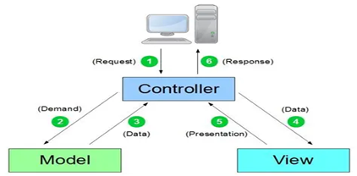

Chapter Four
Design Study of the
Proposed System

4.1 Introduction:
After completing the detailed analysis phase and building the initial diagrams, this chapter will present the design study of the proposed healthcare center management system. The aim of this chapter is to explain the structural and functional models of the system, in addition to clarifying the logical and procedural details that cover all center operations, including patient management, appointments, doctors, and medical notes, along with handling payments and monthly reports.
The chapter also includes design models at different levels, such as user interface designs dedicated to doctors, reception staff, and administrators, in addition to the databases that support all operations to ensure accuracy and fast access to information.
Furthermore, traceability diagrams and Requirement Traceability Matrix (RTM) documents will be included to ensure a clear relationship between requirements and system tests, with the possibility of updating these diagrams in the future to support further development or the addition of new system features.

4.2.1 Class Diagrams:
High level :
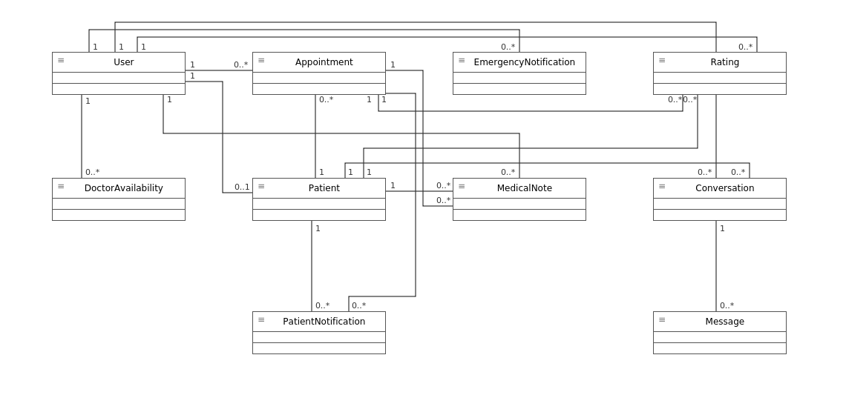

Low level :
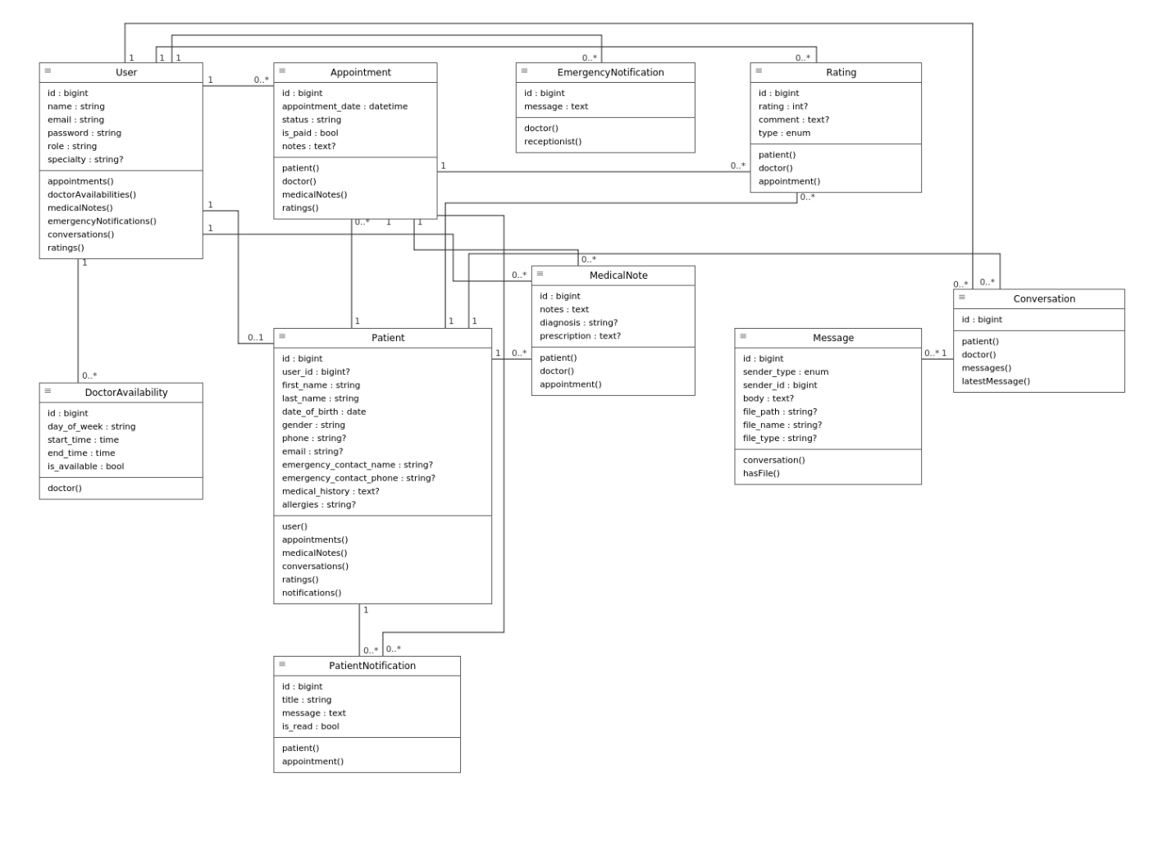

4.2.2 System interface tree:

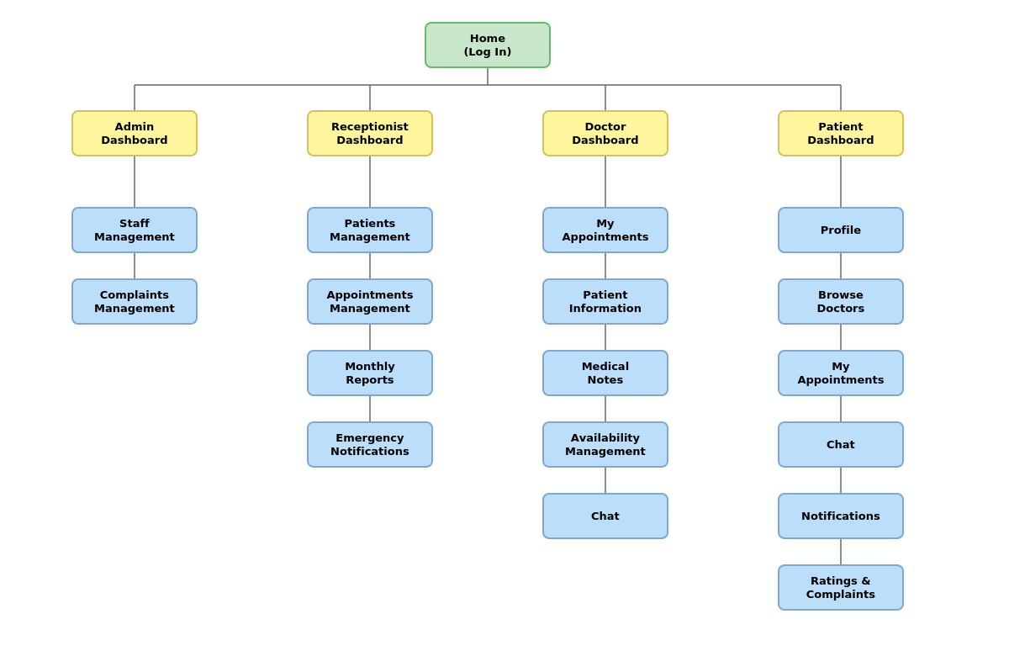

4.2.3 ERD Diagrams:
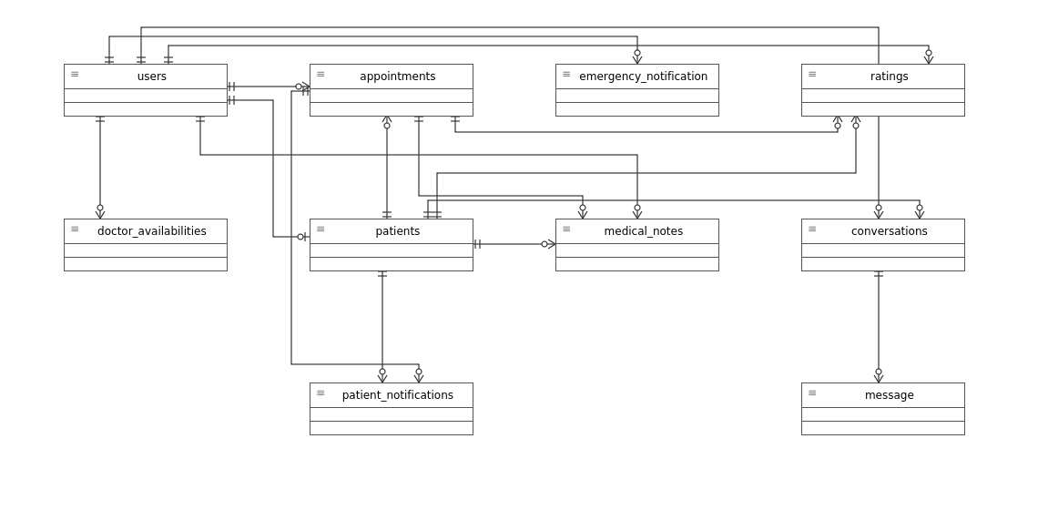
High level:

Low level:

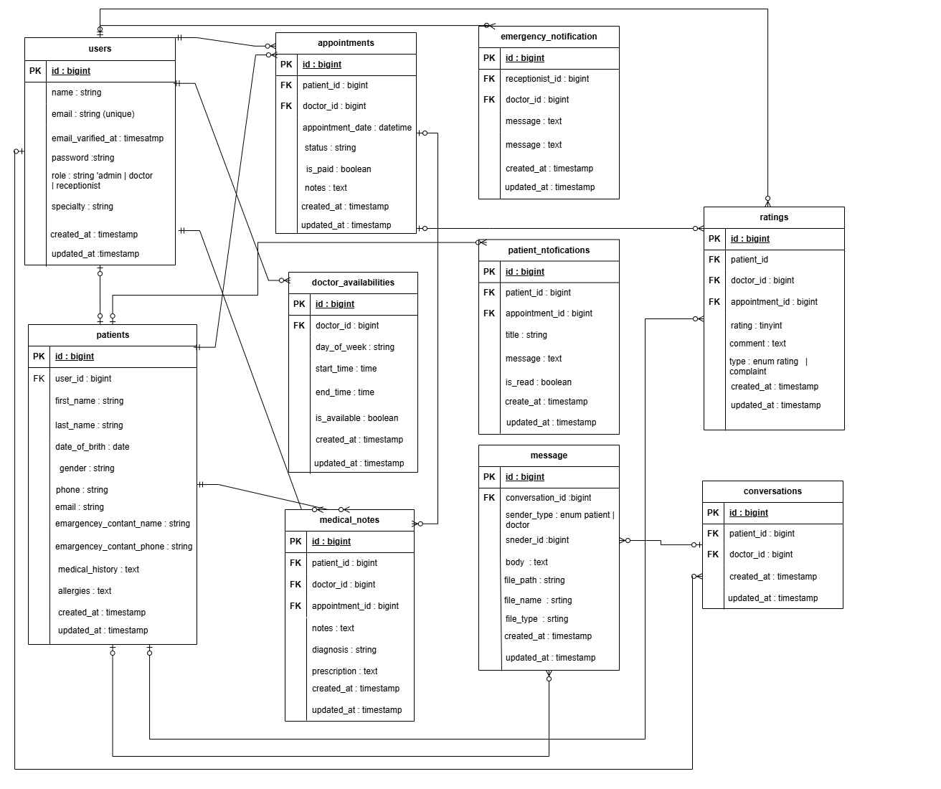

4.3 Summary:
Chapter Four included a presentation of the overall design of the healthcare center management system, where a set of design diagrams was provided to illustrate the structural and functional architecture of the system, contributing to a better understanding of its operation mechanism and core components.
The chapter also reviewed the Requirement Traceability Matrix (RTM), which demonstrates the relationship between the various system requirements and the design and testing phases, ensuring that all functional and non-functional requirements identified during the analysis phase are fulfilled.
This chapter helps provide a solid foundation for moving to the implementation phase while ensuring the system’s maintainability and scalability in the future through a clear and organized design.

Chapter Five
Practical Application

5.1 Introduction:
After completing the creation of diagrams, relationships, and clarifying the algorithms used in the healthcare center management system, this chapter will present the design of the system interfaces and the tools used in its development.
This chapter includes an explanation of the software environment, tools, and technologies used to build the system, along with details about the design of user interfaces and the database, providing a comprehensive understanding of the system’s software and procedural architecture.

5.2 Tools and techniques used


5.2.1 System Tools
1. Draw.io:
It is an open-source software tool used for creating and editing UML models, which is a standard modeling language for representing and designing software systems in a visual way. Draw.io supports a wide range of diagrams, including:
- Class Diagrams: to represent the system structure in terms of classes, interfaces, and their relationships.
- Sequence Diagrams: to represent interactions between objects in a time sequence.
- Activity Diagrams: to represent the flow of processes and activities within the system.
- Use Case Diagrams: to represent interactions between actors and the system.

2. XAMPP:
A free and open-source software package designed to simplify web application development. It includes:
- X (Cross-platform): ability to run on multiple operating systems such as Windows, Linux, and Mac.
- Apache: the web server used to host applications.
- MySQL / MariaDB: database management system.
- PHP and Perl: programming languages used for web application development.

3. Visual Studio Code (VSCode):
An open-source code editor developed by Microsoft, used for writing and editing source code. It is highly flexible and supports many programming languages and libraries, making it a powerful tool for application development.

5.2.2 Used technologies:
1. HTML (Hypertext Markup Language):
A markup language used to create web pages, providing the basic structure of content displayed on the internet.

2. CSS (Cascading Style Sheets):
A styling language used to format HTML pages, such as controlling colors, fonts, spacing, and the overall layout of the page.
3. JavaScript (JS):
A dynamic programming language used to add interactivity to web pages and enhance the user experience.

4. PHP (Hypertext Preprocessor):
An open-source scripting language used to create dynamic and interactive web pages. It is widely used in web application development.

5. Laravel:
An open-source PHP framework used for web application development. It provides tools and features that help developers write clean and well-structured code. Laravel is considered one of the most popular frameworks in the PHP community.

5.3 System Interfaces:

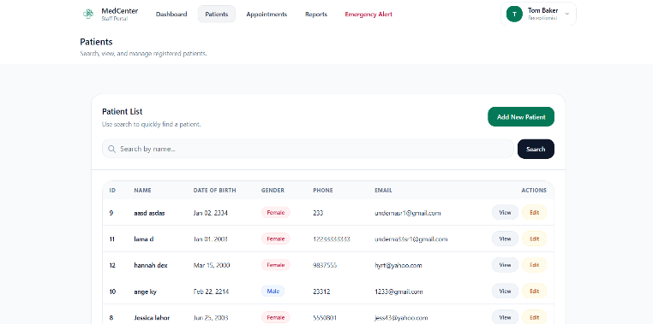
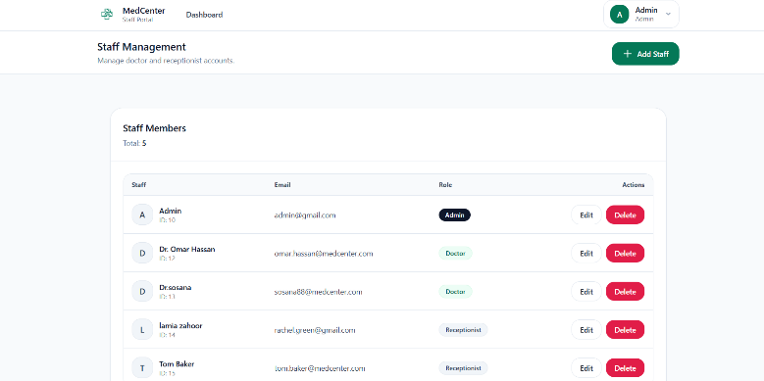
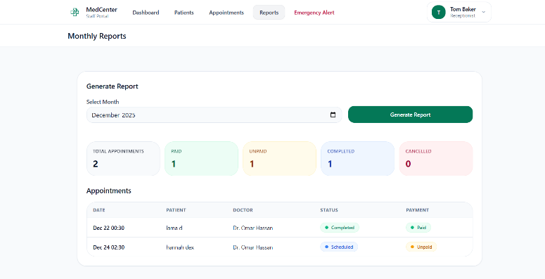
5.3.3: تقارير شهرية
5.3.2: معلومات المرضى
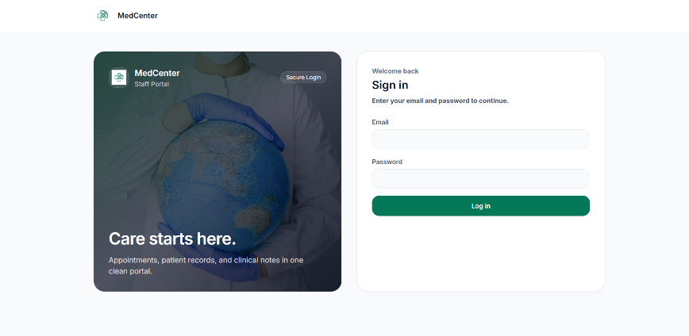

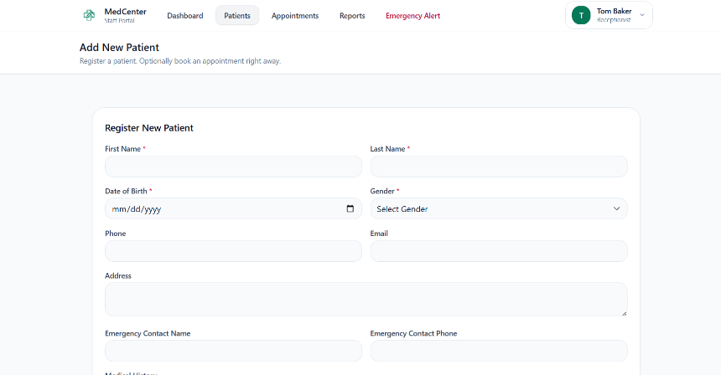

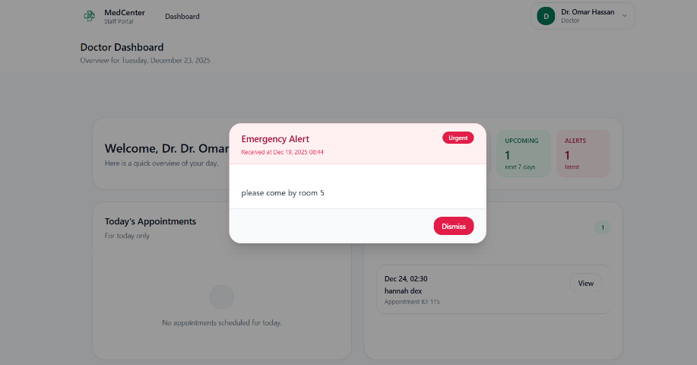

5.4 Summary:
This chapter focuses on explaining all the tools and technologies used in building the healthcare center management system, with a clarification of the role of each tool in developing the different components of the system.
It also presents the interfaces designed and developed for the system, including those for doctors, reception staff, and administrators, to facilitate daily operations and manage data effectively.
This chapter enables developers and users to understand the software environment and technical architecture of the system, and it forms a foundation for the implementation phase, with the possibility of making future improvements or additions to the tools or user interfaces.

Chapter Six
Project Management

Project Description:
MedCenter is a web application built with the Laravel framework The project aims to organize the daily operations of a clinic by managing patients, appointments, staff accounts, and appointment payment status. The system uses role-based access control to define what each user (Admin, Doctor, Receptionist or Patient) is allowed to do
Git:
Version control for the project is managed using Git
GitHub file hosting
- Link: https://github.com/lemsdo-03/medcenter
- Purpose: Contains the full MedCenter project (backend + frontend).
- Structure:
- app/ (controllers, models, middleware)
- routes/ (web routes)
- database/ (data migrations and seeds)
- resources/ (Blade views + assets)
- Documentation files such as VERSION_CONTROL.md
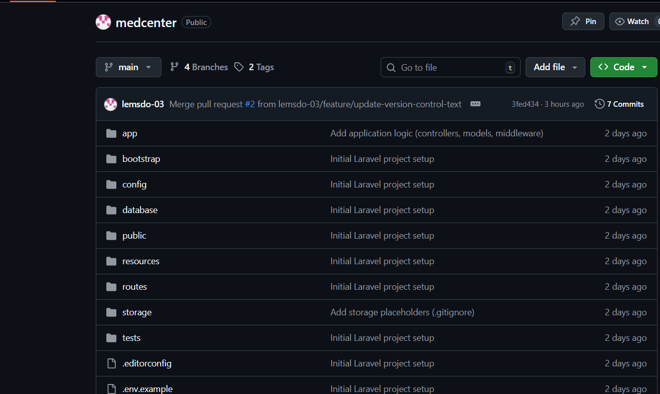

3. Branch and Merge Strategy
Branches Used
- main: the stable branch
- feature: temporary branches for features
Branch Workflow
- A new feature branch is created from the main branch.
- Changes are made and saved in the feature branch.
- A pull request is created to merge the feature branch into the main branch.
- After merging, the main branch contains the updated and stable version.
Examples of branches from this project
- feature/version-control-docs (merged into main)
- feature/update-version-control-text (merged into main).
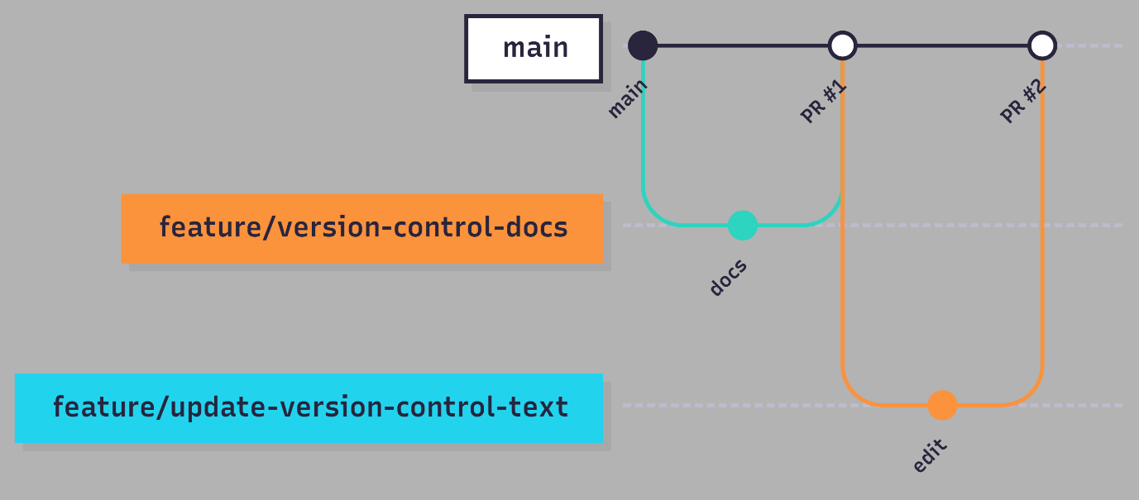

4. Team Members and Responsibilities
The project was developed by a team consisting of two people. All team members participated in the stages of system analysis and architectural design, including requirements analysis, system modeling, and defining the overall system architecture.
Pull Request Guide:
Pull requests were used to merge feature branches into the main branch to keep changes organized and traceable..
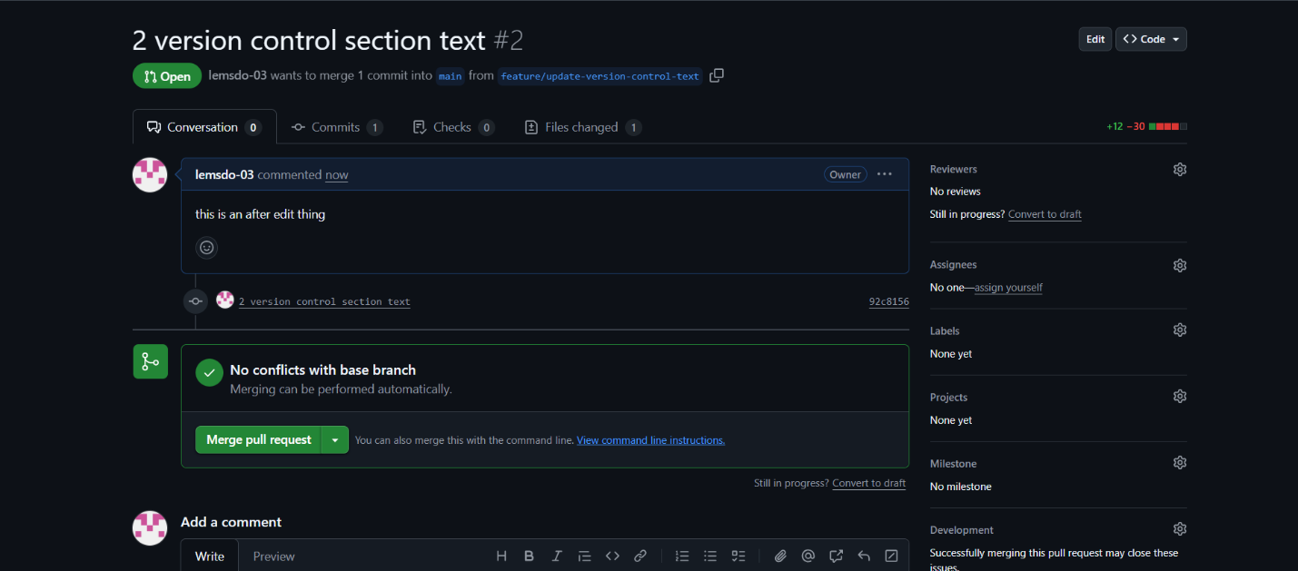

5. Development Workflow
The development workflow of the MedCenter project follows a simplified task-based approach to keep changes organized and traceable using pull requests on GitHub.
The workflow can be summarized as follows:
- Identify a development task: A new task or feature to be developed is identified.
- Create a branch: A new branch named feature/* is created from the main branch.
- Implementation and local testing: Changes are implemented and tested locally on the new branch.
- Save changes: Commits are created with clear messages describing the updates made.
- Push the branch: The feature branch is pushed to the GitHub repository.
- Create a pull request: A pull request is created to merge the feature branch into the main branch.
- Review and merge: After reviewing the changes and obtaining approval, the pull request is merged into the main branch.

6. Tags and Version Management

Git tags were used to identify important milestones of the project and stable delivery versions in the MedCenter repository.
Tagging helps to:
- Identify release points.
- Improve traceability.
- Enable the team to revert to a specific stable state of the code when needed.
The tags created:
- v1.0-final: The final baseline delivery version for the MedCenter project.
- v1.1-docs: An updated version for version control documentation and report enhancements.

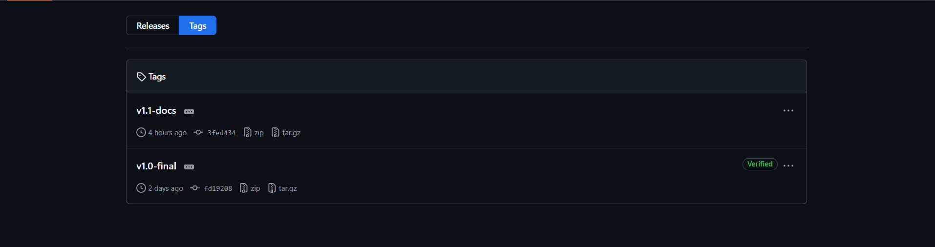

Chapter Seven
Conclusions and References

7.1 Conclusion

This project presented the design and implementation of the Medical Center Management System, a web-based platform built with Laravel and MySQL that organizes the daily administrative and medical operations of a medical center. The system covers four user roles Administrator, Doctor, Receptionist, and Patient each with its own dashboard, permissions, and workflows.
Through this system, medical centers can replace manual processes with a single integrated platform. The system enables receptionists to register patients and book appointments without scheduling conflicts, allows doctors to manage their availability and write medical notes, gives patients self-service access to appointments and chat with their doctors, and provides administrators with staff management and complaint-monitoring tools.
The development followed an iterative and incremental
methodology, with the codebase organized using the
Model-View-Controller (MVC).
Functional and non-functional requirements were systematically
defined, traced through a Requirements Traceability Matrix, and verified through a structured set of test cases.

7.2 Future Work

While the current system delivers the core functionality
identified in the requirements specification, several areas
remain open for future development:
- Real-time chat using WebSockets instead of HTTP polling, to
eliminate the delay between sent and received messages.
- A full billing and payment processing module, beyond the
current paid/unpaid flag on appointments.
- Email and SMS notifications for appointment reminders.
- A mobile-friendly progressive web app (PWA) version for
patients.
- Analytical dashboards with charts and trends, beyond the
current monthly reports.
- Multi-language support, including a fully Arabic interface.

7.2 Future Work

While the current system delivers the core functionality
identified in the requirements specification, several areas
remain open for future development:
A mobile version of the application, so patients and staff
can access their dashboards on the go.
- Multi-language support, including a fully Arabic interface
in addition to the current English one.
- Integration of an AI chatbot into the system to assist
patients with common questions, appointment guidance, and
basic medical information, reducing the workload on
reception staff.

7.3 Final Remarks

The development of this project provided practical experience in
full-stack web development, requirements engineering, database
design, and team-based version control using Git and GitHub.
Beyond its technical outcomes, the project demonstrates how
software can directly improve healthcare administration by
reducing manual effort, preventing errors, and giving each
stakeholder a clearer view of the information they need.

7.4References
Practo | Video Consultation with Doctors, Book Doctor Appointments, Order Medicine, Diagnostic Tests
https://heltog.com
https://www.angelinfotech.org

